Financial Advisor App for Students
Camille Embree, Hoang-Nghi Nguyen

Final Report
Table of Contents
1. Concept of Operations 3
2. Functional System Requirements 18
3. Interface Control Document 34
4. Schedule and Validation 42
5. Frontend Subsystem Report 48
5. Backend Subsystem Report 60

Financial Advisor App for Students
Camille Embree, Hoang-Nghi Nguyen

Concept of Operations

REVISION – 2
26 April 2025
Concept of Operations
for
Financial Advisor App for Students

Team <27>

Approved by:

_____________________________
Project Leader Date

_____________________________
Prof. Nowka Date

_____________________________
T/A Date

Change Record
Rev. | Date | Originator | Approvals | Description
1 | 2/5/2025 | Team 27 |  | Draft Release
2 | 4/26/25 | Hoang-Nghi Nguyen |  | Change in core features from first concept

Table of Contents
List of Figures 7
1. Executive Summary 8
2. Introduction 9
2.1. Background 9
2.2. Overview 9
3. Operating Concept 11
3.1. Scope 11
3.2. Operational Description and Constraints 11
3.3. System Description 12
3.4. Modes of Operations 13
3.5. Users 14
3.6. Support 15
4. Scenario(s) 15
4.1. Budget Planning 15
5. Analysis 16
5.1. Summary of Proposed Improvements 16
5.2. Disadvantages and Limitations 16
5.3. Alternatives 16
5.4. Impact 17

List of Figures
Figure 1. Block Diagram of System 1

Executive Summary
The Personalized Financial Advisor project was developed to help users, particularly students, manage their personal finances more effectively through an intelligent, automated mobile application. The system is designed to capture transaction data, categorize user spending, track budget progress, and provide actionable financial advice in real time, reducing the need for manual financial tracking and lowering the barrier to smart money management.
The application consists of a mobile frontend and a robust Python-based backend. The frontend, built with React Native, allows users to submit receipt images, view categorized expenses, set budget goals, and receive feedback. The backend handles receipt text extraction, transaction categorization, database management, spending aggregation, and financial advice generation. Receipt data is stored securely using Firebase Firestore, and transaction classification is performed using a machine learning ensemble model trained on synthetic receipt datasets. Aggregated spending data is analyzed against user-defined budgets, and personalized financial advice is generated using OpenAI's GPT-4 model.

Introduction
Learning to manage money is an essential skill that everybody should have the opportunity to improve on. It’s particularly important among younger generations who are just beginning their journey to financial independence. This document will outline the main functions of the Personalized Financial Advisor App for Students, a mobile application designed to assist in creating budgets, tracking expenses, and providing financial advice for its users.

Background
Many banking and financial advising apps today isolate single operations such as tracking subscriptions or displaying recent expenses. Having to navigate back and forth between these platforms can make it difficult for users to successfully economize or gain financial skills. To limit this deterrent and save students time, effort, and money, our mobile app will provide a user-friendly hub that incorporates numerous features.
On top of this, the use of artificial intelligence and machine learning will set our app apart from current systems in place. While AI is growing quickly in mobile app development, we will provide unique features such as investment options, financial literature suggestions, and budgeting ideas that are specific to the user based on their recent purchases and recurring payments. Predictive analytics will assist in student’s financial planning.

Overview

Our versatile mobile app will provide easy access to expense tracking, budget creation, and financial advising all in one intuitive platform. Each user will have a personalized experience based on their profile and past purchases.
The interface will provide clear input on where a user stands on their budget each month, allowing them to make informed decisions on their spending. This will include a graphed report of their current progress towards their expense limit along with an actively updated list of purchases.
A tab for planning and tracking a user’s goals will be included as well. Here, the app will suggest articles for financial literacy and recommend relevant investment options. We will also utilize LLM to incorporate a function to scan store receipts to log purchases. To better accommodate students, this page will include suggestions for scholarship opportunities that are fitting with the user information recorded on the account tab.
A payments page will allow users to easily track their bills for rent, subscriptions, and any recurring payments they might have. If applicable, an itemized list for student tuition by semester along with the deadlines will be provided. This function will ensure that people using our app will remain aware of large payments coming up and allow them to plan their savings accordingly.
Lastly, there will be an account tab. This page will prompt users to fill out relevant information such as work experience, the degree they’re pursuing, and their academic year. They can also input details on their current job or income. This data will be utilized to recommend pertinent scholarships or work opportunities in the planning and tracking portion of the app.

Operating Concept

Scope
The Personal Financial Advisor App for Students is designed to assist students in managing their finances by providing insights, tracking spending habits, and offering tailored financial advice for users. The app allows users to log payments from receipts via a camera function and the ability to manually input transactions, which are then categorized and analyzed onto a database to generate reports on their spending patterns. Using Firebase as the database, the app securely stores financial data and user preferences, while the backend, built in Flask, handles user authentication, transaction processing, and data retrieval. The app also includes features such as budgeting tools, savings goals, and reminders for upcoming bills or payments. Constraints include the reliance on accurate user input for categorizing transactions and maintaining an active internet connection for syncing data and receiving advice. Additionally, the app's effectiveness depends on the accuracy of the financial advice algorithms and user engagement, as personalized recommendations are based on the data provided. Privacy and data security are critical considerations, requiring robust encryption and secure authentication mechanisms to protect sensitive financial information.

Operational Description and Constraints
The Personal Financial Advisor App is designed to help students manage their finances by offering personalized insights, budgeting tools, and tailored financial advice. Upon opening the app, students can create an account or log in using Firebase Authentication, ensuring secure access. The primary interaction begins with the dashboard, where students can link their bank accounts or manually input financial transactions. Once linked, the app automatically categorizes transactions into categories such as food, entertainment, transportation, and bills. Students can view detailed spending reports, track monthly expenses, and set budgeting goals directly from the dashboard.

For added convenience, the app offers a transaction input feature where users can manually add receipts or expenses that weren't automatically tracked, entering details like amount, category, and merchant. Based on the financial data, the app provides personalized financial advice, such as tips for saving, reducing unnecessary spending, and suggestions for budgeting improvements. Students can set savings goals and receive notifications for upcoming bill payments or budget milestones.

The app also includes a financial calendar that helps students track important dates, such as scholarship deadlines or loan payments. Interactive charts and graphs display spending trends over time, providing a clear visual representation of their financial habits. Constraints include the need for accurate transaction input to ensure correct categorization and the requirement of an internet connection for syncing data and accessing real-time advice.

System Description
The Personal Financial Advisor App is a mobile application designed to help students manage their finances through intuitive features and personalized advice. The system is composed of three main sub-systems: the mobile app frontend, the backend server, and the Firebase database.
- The frontend, built using React Native, provides a user-friendly interface where students can link their bank accounts, input financial transactions manually, view categorized spending reports, set budgeting goals, and receive personalized financial advice via interactive chat or AI advice generation.
- The backend, developed in Flask, handles user authentication, processes financial data, and communicates with the Firebase database to store transaction history, budgeting goals, and user preferences. An ML model trained with transaction categorization and expense trend detection serves as the structure for AI response sent to the frontend.
- Firebase serves as the cloud-based database, providing secure data storage, real-time synchronization, and authentication services. The system leverages Firebase Authentication to ensure secure user access and uses encrypted communication channels to protect sensitive financial information. The system also incorporates machine learning algorithms to generate tailored financial advice based on the user's spending patterns, helping students optimize their budgets and savings. The app's interactive features, such as the financial calendar and progress tracking, aim to promote better financial habits and help students stay on top of their financial goals.
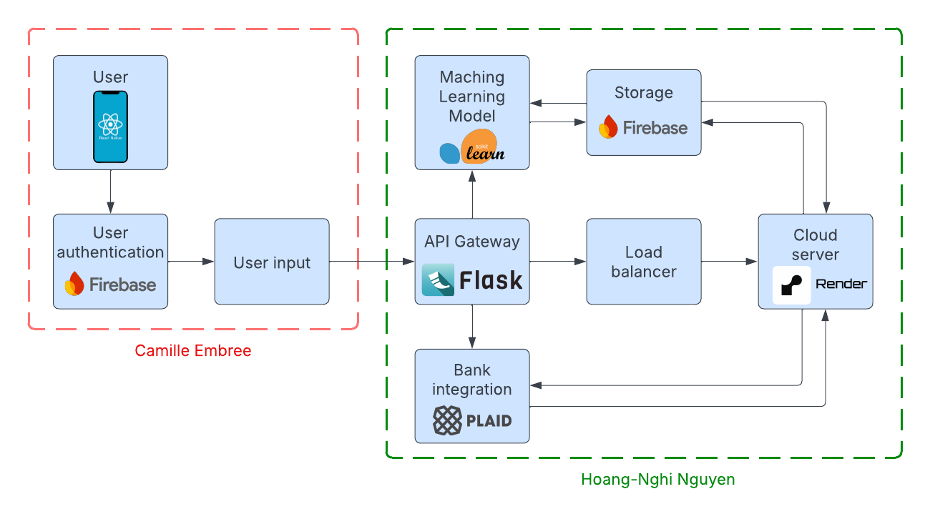
Figure 1. System Units Block Diagram

Modes of Operations
The Personal Financial Advisor App operates in several distinct modes to cater to the needs of the user throughout their financial management process. These modes include:
- User Registration and Authentication: In this function, users create an account or log into the app using Firebase Authentication. Users provide basic personal information and set up secure login credentials. Once authenticated, the user gains access to the app's features, ensuring that financial data remains private and protected.
- Transaction Tracking: This is the core function of the app where users interact with their financial data. Students can manually input transactions by entering details such as the amount, category, merchant, and date, or through the receipt scanning function of the application via the React Native camera function. The system categorizes transactions into predetermined categories like food, entertainment, bills, etc., and updates the user’s financial portfolio in real time.
- Budgeting and Goal-Setting: With this function, users can create and manage budgeting goals for different spending categories such as monthly spending limits for food or entertainment. The app tracks expenses in real-time against the budgeted amounts, alerting users if they are approaching or exceeding their limits. Users can also set savings goals for specific financial milestones, like saving for a trip or an emergency fund, and the app will track progress toward those goals.
- Financial Insights and Advice: Once sufficient data has been accumulated, the app analyzes the user’s spending patterns and provides personalized financial advice. This includes tips for saving, optimizing spending, and setting better budgeting practices based on historical data. The system may also provide suggestions like cutting back on non-essential expenses or recommending more affordable alternatives for recurring payments. Insights are updated regularly based on new transaction data.
- Reporting and Visualization: Users can view comprehensive spending reports and financial charts that show trends over time. The system generates interactive visualizations such as bar graphs and pie charts, which allow students to analyze their spending habits. Reports are updated regularly, providing students with a clear understanding of their financial behavior and how it compares to their established budgets and goals.
- Notification and Reminder: This mode sends notifications and reminders to students about important financial events. For example, users receive notifications for upcoming bill payments, payment due dates for loans, or when they are nearing their budget limits. The app may also remind users about specific savings goals, encouraging them to take action toward meeting those milestones.

- Settings and Profile Management: In this function, users can modify their personal details, configure app preferences, and adjust notification settings. They can also change security settings such as password recovery options and enable multi-factor authentication for increased secure protection.
Each mode operates seamlessly in the background, providing a comprehensive and intuitive experience for users to manage their finances, make informed decisions, and work toward their financial goals.

Users
The primary users of this financial tracking application are college students who need assistance in managing their finances through receipt scanning and expense tracking. The system is designed to be intuitive, requiring minimal training for installation and use.

User Characteristics
- Students (Primary Users)
  - Financial Literacy Level: Varies from beginner to intermediate
  - Technical Knowledge: Basic familiarity with mobile applications
  - Training Required: None; the app is designed for ease of use with a simple onboarding process
  - Benefit: Helps students track expenses, set financial goals, and receive tailored financial advice
- Student Workers & Part-Time Employees
  - Financial Literacy Level: Intermediate
  - Technical Knowledge: Comfortable using mobile finance apps
  - Training Required: Minimal, as the system will automate data entry and categorization
  - Benefit: Helps track income, manage expenses, and budget effectively
- Young Professionals & Recent Graduates (Potential Secondary Users)
  - Financial Literacy Level: Developing
  - Technical Knowledge: Familiar with financial tools and mobile banking apps
  - Training Required: None; self-explanatory UI with guidance for first-time users
  - Benefit: Allows seamless financial tracking for those transitioning to independent financial management
This system is designed for accessibility, ensuring that students and young professionals can manage their finances with minimal effort.

Support

Installation & Usage Training
- Installation: Users will download the app from the App Store (iOS) or Play Store (Android). A setup wizard will guide them through account creation.
- Usage: No training is needed for users that are familiar with mobile devices. Users can scan receipts, review transactions, and get financial insights with simple on-screen instructions.
- Support: FAQs and help documentation will be available within the app.

Scenario(s)

Budget Planning
It can be difficult for students who might be new to maintaining their own personal finances to create reasonable budgets. Our app will include a model that informs its users on popular financial plans that are relevant to them based on their account information and expenses. This will allow for easy and successful budgeting, along with a straightforward way to view progress towards a monthly spending goal.
  - Financial Education and Coaching
It’s vital for students to begin monetary education early so that they can apply practices now and prepare for when they begin seeing increased earnings post-graduation. In the financial education and coaching tab, our app will employ account information along with purchase details input by the user through our receipt scanning function. It will then utilize a machine learning model to recommend suitable financial literacy, investment options, and potential scholarships. This will provide student users with a solid foundation of economic skills for present and future use.
  - Expense Tracking
The average student has a plethora of tasks to complete in a day, so adding seemingly unnecessary chores such as tracking expenses can feel daunting. Our app will aid in relieving some of this stress and encouraging users to keep up with their recent and upcoming expenses. The planning and tracking tab will provide clear information on upcoming bill payments, subscriptions, and recurring payments. It will also have the option to provide an itemized list for student tuition by semester along with a deadline. The easy to navigate interface will allow students to quickly get reminders on these expenses and save accordingly.

Analysis

Summary of Proposed Improvements
Our personalized financial advisor app for students will include multiple improvements from current financial advisor apps including the following:
- Implementing artificial intelligence and machine learning will allow for real-time personalized feedback for users.
- Providing relevant financial literature will save students time and effort from having to complete research on their own.
- The easy to navigate interface will help students view their budgeting goals clearly and stick to a schedule with ease.
- Our machine learning model will allow users to input purchases more easily by scanning their receipts.
- Using React Native will allow for simple and readable code along with smooth cross-platform use.

Disadvantages and Limitations
Some of the disadvantages and limitations of the application include:
- While React Native is beneficial in many ways, one downside is that it typically has a larger app size. This may lead to slower download times or deter users from installing the app.
- This framework also has limitations on the complexity of features/animations available.
- Using Python Flask limits the size of our project to small/medium.

Alternatives
- A couple of alternatives to React Native for mobile app front-end design include Flutter and Ionic. While we did consider using one of these frameworks, React Native was compatible with both IOS and Android despite the extra time and effort it takes to implement. It also provided an easier to decipher code style and language being based largely on JavaScript.
- Node.js and Ruby are both common alternatives for back-end languages. While they do allow for quicker execution and development, Python Django or Flask have more accessibility for implementing machine learning and artificial intelligence.

Impact
Some potential impacts of our personalized financial advisor app are listed below:
- If our AI model suggests a cheaper alternative to a product that a user buys often, it might be less environmentally friendly.
- While finances are important, it is also vital to find a balance between taking care of oneself and saving money. It’s important we ensure that our app doesn’t have the potential to instill unhealthy habits to budget.
Financial Advisor App for Students
Camille Embree, Hoang-Nghi Nguyen

Functional System Requirements

REVISION – Draft
20 February 2025
Functional System Requirements
for
Financial Advisor App for Students

Prepared by:

_____________________________
Author Date

Approved by:

_____________________________
Project Leader Date

_____________________________
John Lusher, P.E. Date

_____________________________
T/A Date

Change Record
Rev. | Date | Originator | Approvals | Description
1 | 2/20/2025 | Financial Advisor App for Students |  | Draft Release

Table of Contents
List of Figures 22
1. Introduction 23
1.1. Purpose and Scope 23
1.2. Responsibility and Change Authority 23
2. Requirements 24
2.1. System Definition 24
2.2. Characteristics 25
2.2.1. Functional / Performance Requirements 25
2.2.2. User Interface and Experience 26
2.2.3. Data Handling and Security 28
2.2.4. System Scalability and Integration 29
2.2.5. Error Handling and Fault Tolerance 30
3. Support Requirements 31
Appendix A: Acronyms and Abbreviations 32
Appendix B: Definition of Terms 33

List of Figures
Figure 1. Block Diagram of System 1

1. Introduction

Purpose and Scope
Managing budgets and gaining financial education is a pivotal aspect of every student’s experience. The Personalized Financial Advisor App for Students will allow users to easily go about this by displaying relevant financial information in a clear and engaging format. It will begin by connecting with a student's bank account and data mining to get an idea of how much they spend on certain items. The system shall use Plaid to ensure privacy. It shall use Firebase to store pertinent user data and provide security. It shall then use a machine learning model to suggest budgets that may be beneficial to the student based on their specific habits. Once the student has selected a financial plan, it shall be conveniently displayed on the home page in an aesthetically pleasing format. The app should also recommend relevant articles, scholarship opportunities, credit building tips, and more on a separate tab. The UI and database shall be connected through a secure API request.

All of these features will aid students in practicing imperative skills such as economizing which will allow them to accumulate less debt, fill necessary financial obligations, and relieve some of the stress surrounding money management.

Responsibility and Change Authority

Briefly describe who has the responsibility for making sure the requirements are met (i.e., team leader) and who has the authority to make the changes (i.e., client and team leader).

Hoang-Nghi Nguyen will have the responsibility of making sure that the requirements for the back-end coding are met. This includes creating a functioning machine learning model using Sci-kit, providing an organized database for storage, and integrating a secure bank account connection.

Camille Embree, on the other hand, will be responsible for ensuring that the requirements for the front-end coding are met. This will include drafting a user-friendly interface that includes three main components (home, analysis, and education tab), as well making sure that the front and back end are smoothly integrated.

Each member will have the authority to make changes to their respective subsystems under the consensus of the team and acceptance of our sponsor, Niloofar Borzooei.

Requirements

System Definition

Our project, the Personalized Financial Advisor App for Students, is a mobile application designed to facilitate budgeting and gaining financial education for its users. It will succeed in this task by following the block diagram below which has been split into two main subsystems, a front-end and a back-end.

Figure 1. Block Diagram of System

The front-end of this project will primarily focus on building a user-friendly interface for students to easily view their current budget progress, an analysis of their spending, and resources to build financial literacy. It shall be straightforward and comprehensible as well as engaging so that students don’t forget to check it and utilize all of the functions available.

Characteristics

Functional / Performance Requirements

API Response Time Test
The financial tracking application must maintain efficient performance, with API response times of ≤ 500ms under normal load. This ensures that user requests, such as transaction fetching and data updates, are processed quickly without delays. Performance testing should identify potential bottlenecks in Flask API endpoints to optimize response times.

Rationale: Fast response times are essential to ensuring a smooth user experience. Delays in fetching or updating financial data may frustrate users and impact usability. The 500ms threshold aligns with best practices for mobile applications and ensures near-instantaneous feedback when interacting with financial data.

Bank Transaction Fetching
The system must successfully retrieve and update bank transactions for authenticated users from Plaid API. This ensures that users always have access to their latest financial data. The API integration should be tested with valid and invalid credentials to verify authentication and error-handling mechanisms.

Rationale: Users rely on real-time updates to track their financial status. If transactions are not retrieved properly, users may make decisions based on outdated information. This requirement ensures reliable transaction fetching, preventing discrepancies between the app and the user’s bank.

ML Model Accuracy
The machine learning model should classify and analyze user spending patterns with an accuracy of at least 85%. Test datasets with labeled transactions will be used to validate the accuracy of the model’s categorizations, ensuring that expenses are grouped correctly into categories such as "Food," "Rent," and "Entertainment."

Rationale: Accurate expense categorization helps users understand their spending habits and budget effectively. A lower accuracy rate could lead to misclassified expenses, reducing trust in the system and requiring manual corrections.

Database Read/Write Performance
Read and write operations to Firebase Firestore should complete in ≤ 200ms for 90% of requests to ensure real-time transaction categorization and user updates. Performance tests should simulate concurrent database operations, including fetching transactions and storing new data.

Rationale: The app relies on real-time data synchronization to reflect updates instantly across devices. Slow database performance could cause laggy interfaces, outdated financial insights, or even synchronization failures. A 200ms threshold ensures smooth interactions without noticeable delays.

End-to-End Module Functionality
Each core feature of the application, including authentication, transaction retrieval, machine learning-based categorization, and UI updates, should function correctly in isolation and together as a complete system. Individual module tests will verify that API calls, ML predictions, and database interactions work as expected.

Rationale: A failure in any core module could render the application unusable. Testing each module separately ensures stability, while integrated testing guarantees that components interact as expected. This is critical for maintaining data consistency and preventing functional breakdowns.

User Interface and Experience

Home Tab
The home page should provide users with a comprehensive financial overview in an easy-to-navigate format. Users should be able to check their budget status quickly, with a learning curve of no more than four minutes. Testing will involve usability evaluations with groups of five students.

Rationale: Users should not feel overwhelmed when accessing their financial information. A simple and intuitive home page improves engagement and retention. The four-minute threshold ensures that even non-tech-savvy users can quickly understand the interface.

Tracking/Analysis Tab
This tab should display clear and visually informative charts and graphs about recent spending patterns. The graphs must be accurate and update dynamically based on the user's financial activity. Usability tests will ensure the effectiveness of the visual representation.

Rationale: Raw transaction data can be difficult to interpret. Visual representations (charts and graphs) help users quickly grasp spending patterns, identify trends, and adjust their budget. The accuracy of these visualizations is critical to preventing misleading financial decisions.

Financial Literacy Tab
The financial literacy tab should offer educational content related to financial strategies, budgeting, and investment opportunities. The information must be engaging and visually appealing. Five students will review three different financial literacy content layouts to determine accessibility.

Rationale: Many students lack formal financial education. A dedicated financial literacy section provides users with knowledge, helping them make informed spending and saving decisions. Having an engaging presentation of content ensures that users stay interested and benefit from the information.

Account Page
The account page should securely store and display user information. All user inputs must be validated against a test database to ensure correctness. Testing will involve submitting valid and invalid user data and verifying proper handling.

Rationale: Security is a top priority when handling financial data. Invalid or incomplete inputs could lead to authentication issues or data corruption. Ensuring strict input validation enhances system reliability and prevents unauthorized data access.

Sounds
The application should include auditory feedback when users interact with buttons or select options. A sandbox environment will be used to verify that sounds are played correctly at least 95% of the time when a relevant button is pressed.

Rationale: Sound cues provide instant confirmation that an action has been registered. Missing or incorrect audio feedback can lead to user confusion, especially for visually impaired individuals or users navigating quickly.

Alerts
Push notifications should remind users of budget limits or suggest lower-priced alternatives. Alerts must be delivered reliably, and tracking in the Apple Push Notification Console will confirm successful message delivery.

Rationale: Notifications help users stay on track with their budgeting goals. If users are not reminded of overspending or available savings opportunities, they may miss chances to improve their financial health.

Data Handling and Security

Secure Transaction Storage
All financial transaction data must be securely stored in Firebase Firestore with encryption enabled. Testing will verify that transactions are stored correctly and cannot be accessed without proper authentication.

Rationale: Financial transactions contain sensitive personal information. Encryption ensures data security and compliance with best practices for financial applications.

Authentication and Access Control
User accounts must be protected with secure authentication mechanisms, including password encryption and Firebase Authentication. Tests will include login attempts with incorrect passwords and unauthorized access attempts.

Rationale: Protecting user accounts from unauthorized access is essential. Firebase Authentication provides a secure, industry-standard mechanism for login and account recovery.

Data Integrity and Validation
The system must prevent invalid or incomplete data entries. All user inputs should be tested against predefined integrity rules to ensure correctness. Invalid transactions should be rejected to maintain accurate financial tracking.

Rationale: Incorrect or corrupted data compromises accuracy. Validation ensures data reliability, preventing duplicate or inconsistent records.

API Security and Error Handling
Flask API endpoints must handle errors properly, including invalid transaction data and unauthorized access attempts. Testing will include sending incorrect API requests and verifying proper error messages are returned instead of system crashes.

Rationale: Proper error handling is critical for security and usability. Without it, invalid inputs or unauthorized access attempts could cause system crashes or expose sensitive information. Clear and structured error messages help users understand issues while preventing attackers from exploiting vulnerabilities. Implementing proper error handling ensures system stability, security, and a better user experience.

System Scalability and Integration

Backend API Performance
The Flask backend must handle increasing numbers of concurrent users and API requests without performance degradation. Load testing will simulate multiple concurrent requests to ensure the system remains responsive.

Rationale: As more users join the platform, the backend must scale efficiently. Ensuring API performance prevents slowdowns or crashes due to high traffic.

Frontend-Backend API Integration
The React Native frontend must communicate smoothly with the Flask backend. API responses should be properly formatted and displayed in the UI without breaking the application. Testing will include sending incorrect API data and observing error handling.

Rationale: Seamless frontend-backend communication ensures that users always see updated and consistent data. Improper integration could cause UI glitches or incorrect financial insights.

Handling Edge Cases
The system should be resilient against unusual inputs, such as empty transaction histories, duplicate entries, or corrupted data. Edge case testing will verify that such conditions do not cause crashes or incorrect calculations.

Rationale: Handling edge cases prevents system crashes and ensures accurate calculations. It ensures the app remains stable and reliable, even with unexpected inputs, enhancing user trust and experience.

Future Scalability Considerations
The system must be designed to integrate additional financial data sources and expand machine learning capabilities without requiring major architectural changes.

Rationale: Building for scalability ensures the system can grow and adapt to future requirements without significant changes. This flexibility supports long-term sustainability and allows for the addition of new features, improving the app’s value and performance over time.

Error Handling and Fault Tolerance

Transaction Categorization Accuracy
Transactions retrieved from Plaid must be correctly categorized and stored. Sample transaction data will be used to verify whether categories like "Food" and "Rent" match expected classifications.

Rationale: Poor categorization can lead to misleading financial reports. Ensuring correct classification reduces user corrections and improves budgeting insights.

Expense Tracking Consistency
The expense tracking feature must maintain long-term consistency in financial calculations. Simulated expense entries will be tested over extended periods to validate tracking accuracy.

Rationale: Users rely on expense tracking for long-term budgeting. If calculations become inconsistent, financial predictions and budgets will be inaccurate, leading to poor decision-making.

API Failure Handling
The backend must handle API failures gracefully, providing appropriate error messages rather than crashing. Tests will simulate scenarios such as Plaid being temporarily unavailable.

Rationale: Third-party API failures are unavoidable, but system crashes can be prevented. Proper error handling ensures users are informed of issues rather than experiencing app failures.

User Error Recovery
Users must be able to recover from input errors without data loss. Testing will involve incorrect inputs in forms and ensuring users can correct mistakes easily.

Rationale: Mistakes in financial apps are common. Allowing users to correct errors prevents frustration and ensures data accuracy.

Alert System Reliability
Push notifications must deliver accurate and timely alerts regarding spending limits and budget warnings. A test environment will track whether alerts are successfully received on mobile devices.

Rationale: Ensuring reliable alerts is essential for user engagement and financial management. Timely, accurate notifications help users stay on top of their spending, while proper testing guarantees that the system delivers critical alerts without failure. This enhances user experience and helps maintain the app’s reliability.

Support Requirements
In order to display our app system as expected, users will require a mobile device of IOS version 13.4 or above. They may also use an Android device of version 6 or above, however the layout likely won’t be as functional and IOS is recommended.
The financial tracking app will require a comprehensive support system to ensure smooth operation, user satisfaction, and long-term success.
- User Support: Users should have access to clear documentation, FAQs, and self-help resources, as well as responsive support through live chat or email for resolving issues such as login problems, transaction disputes, or feature inquiries.
- Technical Support: The backend and infrastructure should be regularly monitored for potential issues, such as server downtime, database errors, or API failures. Timely bug fixes and system updates will be essential for maintaining reliability.
- Security and Data Integrity: Continuous monitoring and prompt patching of security vulnerabilities, including data breaches, authentication issues, and encryption, will be crucial. Regular audits and compliance checks will also ensure the protection of sensitive user data.
- Scalability Support: As the app grows, support will be required for scaling both the infrastructure and feature set. This includes optimizing server performance, expanding data storage capabilities, and managing additional financial data sources or machine learning models.

Appendix A: Acronyms and Abbreviations

API Application Programming Interface
DB Database
JSON JavaScript Object Notation
ML Machine Learning
NoSQL Not Only SQL
REST Representational State Transfer
SDK Software Development Kit
UI User Interface
UX User Experience
ICD Interface Control Document

Appendix B: Definition of Terms
API (Application Programming Interface): A set of protocols, tools, and definitions that allow different software applications to communicate with each other. In the context of the app, the API facilitates data exchange between the frontend (React Native) and backend (Flask).

DB (Database): A system used to store, manage, and retrieve data. In this project, Firebase Firestore is used as the NoSQL database to store user information, transaction records, and other financial data.

JSON (JavaScript Object Notation): A lightweight, text-based data format used for exchanging data between the client (frontend) and server (backend). JSON is easy for both humans and machines to read and write.

ML (Machine Learning): A subset of artificial intelligence that involves the use of algorithms and statistical models to analyze data, learn from it, and make predictions. In this project, ML is used for extracting financial data from receipts and providing personalized financial advice.

NoSQL (Not Only SQL): A type of database designed to handle unstructured or semi-structured data. Firestore, a NoSQL database, is used in this project to store dynamic, scalable user and financial data.

REST (Representational State Transfer): An architectural style for designing networked applications. RESTful APIs use standard HTTP methods (GET, POST, PUT, DELETE) to manage data and ensure stateless interactions between the client and server.

SDK (Software Development Kit): A collection of tools, libraries, and documentation that help developers build applications. For this project, SDKs from third-party services like Plaid are used to integrate bank transaction data into the app.

UI (User Interface): The visual part of the application that users interact with, including elements like buttons, forms, and navigation menus. A well-designed UI ensures a smooth user experience.

UX (User Experience): The overall experience of a user when interacting with an application, focusing on ease of use, satisfaction, and efficiency. A strong UX design ensures that users can easily navigate and engage with the app.

Financial Advisor App for Students
Camille Embree, Hoang-Nghi Nguyen

Interface Control Document

REVISION – Draft
20 February 2025
Interface Control Document
for
Financial Advisor App for Students

Prepared by:

_____________________________
Author Date

Approved by:

_____________________________
Project Leader Date

_____________________________
John Lusher II, P.E. Date

_____________________________
T/A Date

Change Record
Rev. | Date | Originator | Approvals | Description
1 | 2/2/2025 | Financial Advisor App for Students |  | Draft Release

Table of Contents
1. Overview 38
2. References and Definitions 38
2.1. References 38
2.2. Definitions 38
3. Frontend Interface 39
3.1. Mobile Operating Systems 39
3.2. React Native Libraries 39
4. Backend Interface 40
4.1. Scope 40
4.2. API Communication Protocols 40
4.3. Authentication and Authorization 40
4.4. Third-Party Integrations 40
4.5. Data Management and Storage 40
4.6. Error Handling and Responses 40
4.7. API Rate Limiting 40
5. Machine Learning Interface 41
5.1. ML Model Integration 41
5.2. Data Flow and Feature Extraction 41
5.3. Model Predictions and Feedback 41
5.4. Training and Evaluation 41

Overview
The Interface Control Document defines the interactions and communication between the Frontend (React Native) and the Backend (Flask API) of the Personalized Financial Advisor App for Students. This document outlines the communication protocols, system interfaces, and the operational constraints that will ensure that all components of the financial tracking app (frontend, backend, and machine learning) work seamlessly together, providing users with an intuitive and secure experience while managing their finances.

References and Definitions

References
Refer to section 2.3 of the Concept of Operations document.

Definitions
API Application Programming Interface
DB Database
JSON JavaScript Object Notation
ML Machine Learning
NoSQL Not Only SQL
REST Representational State Transfer
SDK Software Development Kit
UI User Interface
UX User Experience
ICD Interface Control Document

Frontend Interface

Mobile Operating Systems
This mobile application was built for IOS of versions 13.4 and above. Android users of version 6 and above are also able to download and use the app, however functionality will be limited.

React Native Libraries
In order to write code for the front-end of this project, numerous React Native libraries were necessary. Some examples of these main libraries include react navigation and react native button.

Backend Interface

Scope
The backend is responsible for processing API requests from the frontend, storing data, authenticating users, integrating with external services, and performing financial calculations.

API Communication Protocols
The Flask API will use RESTful APIs for communication with the frontend. Data will be transmitted in JSON format, ensuring efficient and structured data exchange.

Authentication and Authorization
The backend will use JWT for secure user authentication. Only authenticated users will be able to access their financial data, ensuring security and privacy.

Third-Party Integrations
The backend will integrate with external services such as Plaid to retrieve transaction data. The backend will also be responsible for securely communicating with the Firebase Firestore database and managing interactions with the machine learning models.

Data Management and Storage
The backend will interface with Firebase Firestore, storing transaction records, receipts, budgets, and user profiles. Data will be encrypted and secured to protect user privacy.

Error Handling and Responses
The backend will return appropriate HTTP status codes (e.g., 400 for bad requests, 401 for unauthorized access) and structured error messages to help the frontend handle issues gracefully.

API Rate Limiting
External integrations (such as Plaid) will impose rate limits on API requests. The backend will implement mechanisms to handle rate limiting, including queueing requests or notifying users of delays.

Machine Learning Interface

ML Model Integration
The backend will integrate with the machine learning models for transaction categorization. This will enable the system to automatically classify transactions into categories such as food, entertainment, transportation, etc., based on user spending patterns.

Data Flow and Feature Extraction
Transaction data sent from the frontend will be preprocessed on the backend. Relevant features (transaction amount, date, merchant name) will be extracted for use in the machine learning model.

Model Predictions and Feedback
Once a transaction is processed, the ML model will predict its category. The model’s output will be sent back to the frontend, where it will be displayed to the user. The system will also allow users to correct or adjust predictions, and the model will improve over time with feedback.

Training and Evaluation
The machine learning models will be periodically retrained using new data to improve accuracy. The system will evaluate model performance based on the precision of the categorization and user feedback.

Financial Advisor App for Students
Camille Embree, Hoang-Nghi Nguyen

Schedule and Validation
Table of Contents
1. Execution Plan 45
2. Validation Plan 46

List of Tables
Table 1. Execution Plan Timeline 45
Table 2. Validation Plan 46

- Execution Plan

The execution plan for the personalized financial advisor app for students can be found below in Table 1. The table was built by considering the amount of hours that would be dedicated to each task, and planning out those assignments chronologically based on these estimates. While we did fall behind during weeks 3/23-3/30, we were able to quickly readjust and complete all of our tasks for the first semester.

Table 1. Execution Plan Timeline
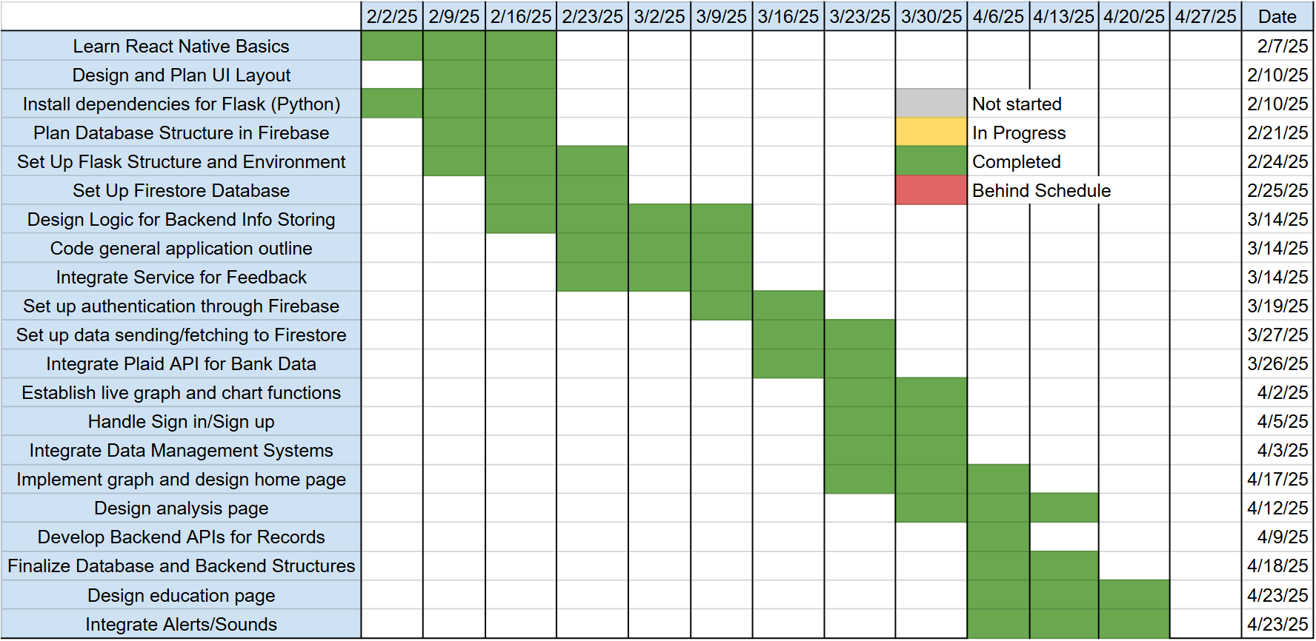

- Validation plan

The validation plan for our application can be found below in Table 2. The blue represents backend structures, and the orange displays frontend operations. Each test can be associated with the respective paragraph in the Functional System Requirements section found above. There, you can find more detailed information about the purpose and validity of each test.

Table 2. Validation Plan
Paragraph # | Test Name | Success Criteria | Methodology | Status | Responsible Engineer(s)
2.2.1.1 | API Response Time Test | API response time should be ≤ 500ms under normal load. | Use Postman or to send multiple requests to Flask endpoints. Identify bottlenecks using Flask debugging and profiling tools. | DONE 4/24/25 | Hoang-Nghi Nguyen
2.2.1.2 | Bank Transaction Fetching | The system successfully fetches and updates bank transactions for sandbox simulation tests. | Simulate API calls to Plaid with valid and invalid credentials. Monitor response times and error handling when Plaid's service is down. | DONE 4/24/25 | Hoang-Nghi Nguyen
2.2.1.3 | ML Model Accuracy | The ML model provides at least 85% accuracy in classifying transactions | Feed test datasets with labeled transactions and compare output classifications. | DONE 4/14/25 | Hoang-Nghi Nguyen
2.2.1.4 | Database Read/Write Performance | Read/write operations complete in ≤ 200ms for 90% of requests. | Simulate concurrent database queries (fetch transactions, store new data). | DONE 3/3/25 | Hoang-Nghi Nguyen
2.2.1.5 | End-to-End Module Functionality | Each core app function works correctly, including authentication, data fetching, ML analysis, and storage. | Test individual modules in isolation (e.g., authentication, API calls, ML predictions). | DONE 4/14/25 | Hoang-Nghi Nguyen
2.2.1.6 | Transaction Categorization & Display | Transactions retrieved from Plaid are correctly categorized, stored, and displayed in the app. | Fetch sample transactions and check if categories (e.g., "Food", "Rent") match expected results. Validate ML model outputs for accuracy and consistency. Check if categorized data is stored properly in Firebase Firestore. | DONE 4/14/25 | Hoang-Nghi Nguyen
2.2.1.7 | Expense Tracking & Budgeting | The app correctly tracks user expenses and provides budgeting insights without errors. | Input various expense types and verify that total spending updates correctly. Compare budget warnings/recommendations with expected calculations. Simulate multiple expense entries over time to ensure long-term tracking consistency. | DONE 4/14/25 | Hoang-Nghi Nguyen
2.2.2.1 | Home Tab | The home page of our app will provide helpful and comprehensive material on current budget status and take no more than 4 minutes to learn how to navigate. | Groups of five students will be tasked to engage with the home page and understanding will be assessed and polled. | DONE | Camille Embree
2.2.2.2 | Tracking/ Analysis Tab | This tab will provide accurate and legible charts and graphs regarding the users recent spending. | Sets of test data will be written into the application and user tests will be conducted with five students to determine comprehensiveness. | DONE | Camille Embree
2.2.2.3 | Financial Literacy Tab | Relevant and helpful information such as financial articles, scholarship opportunities, and investment recommendations will be displayed in an engaging and user friendly manner. | Five students will be asked to view three sets of example financial literacy tabs and determine how accessible and visually engaging they are. | DONE | Camille Embree
2.2.2.4 | Account Page | The account page will accept only valid user information and store the data securely. | Run a method to pull sets of valid and invalid inputs out of a test database and ensure that each value successfully returns true or false. | DONE | Camille Embree
2.2.2.5 | Sounds | The application will produce sounds to indicate certain buttons/options being selected. | A sandbox environment will be utilized to ensure that the correct sound goes off 95% of the time each vocal button is pressed. | DONE | Camille Embree
2.2.2.6 | Alerts | Push notifications will be sent to users who so choose, reminding them of budgetary status or lower-priced options. | Send and track a minimum of ten push notifications to mobile device using the Delivery Log within the Apple Push Notification Console. | DONE | Camille Embree

Financial Advisor App for Students
Camille Embree

Frontend Subsystem Report
Table of Contents
List of Figures 50
1. Introduction 51
2. Navigation 52
2.1. Homescreen 53
2.2. Analysis Tab 54
2.3. Education Tab 54
2.4. Code 54
3. Firebase 57
3.1. Authentication 57
3.2. Firestore Database 58
3.3. Storage 58
3.4. Messaging 59

List of Figures
Figure 1. Sign in and Create Account Pages 52
Figure 2. User Interface of Three Main Tabs 53
Figure 3. Overview of Code File Organization 55
Figure 4. Primary stack Screen Organization Found in app/_layout.tsx 55
Figure 5. Collapsed Version of Tab Organization Found in app/(tabs)/_layout.tsx 56
Figure 6. Code Snippet of app/hooks/userAuthentication.tsx 57
Figure 7. Firestore Organization and Document Creation 58
Figure 8. Code Sending an Acception User Image to Storage 58
Figure 9. Code Sending a Newly Permitted Token to the Firestore 59

Introduction
The purpose of this report is to provide a description of the frontend operations of the personalized financial advisor app for students. These primarily include UI design and development, database structure and implementation, and functions such as camera use and notifications.

The first focus will be the navigation and UI aspects of the frontend development. Here we will explore each of the three main tabs and their purposes, as well as provide an overview of the applications navigation/functionality. Some code snippets will be provided to explore the general layout files. This paper will then discuss the firebase organization and what services are utilized for this project.

The goal of the frontend development was to create a user-friendly interface to display vital financial information and the outputs of our machine learning model. It will encourage student users to easily track and improve their budgets as well as continue to grow their money management skills. It has successfully achieved this through simple, clean design and clear instructions on each page.

Navigation
The following section will detail the user interface displays and basic navigation of the application. This will include details on the purpose and functionality of each page.

When a user first opens the application, they are brought to a sign in page. They have options to either enter their information if they already have an account or navigate to a separate sign up page if they’d like to create a new account. If they have already signed up but have forgotten their password, there’s a link that allows them to reset it through an emailed link. These pages can be found below in Figure 1. If a new account is created, a user will be sent to a page prompting them to verify their email address through a link that had been sent to them. After accepting the link from their inbox, they will be sent to the home page seen in Figure 2 below. Upon this first navigation, a modal appears on the home screen describing the meaning of the graph, list, and different functional buttons. Similarly, a modal is displayed upon first navigation to the analysis and education pages, describing the tabs and how to use them.

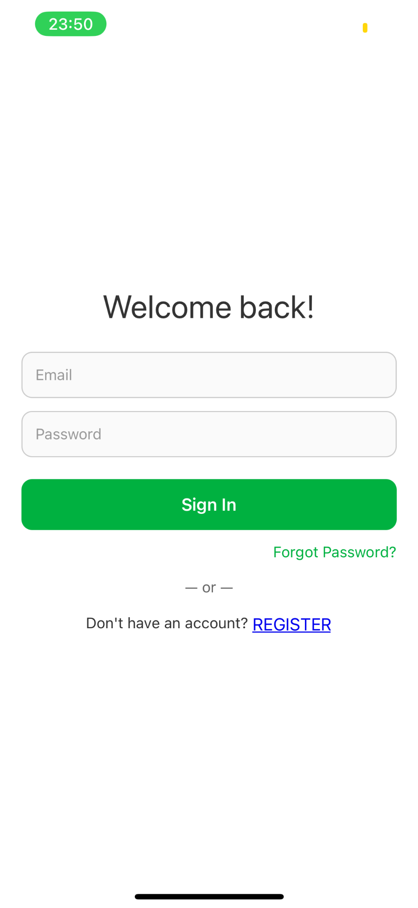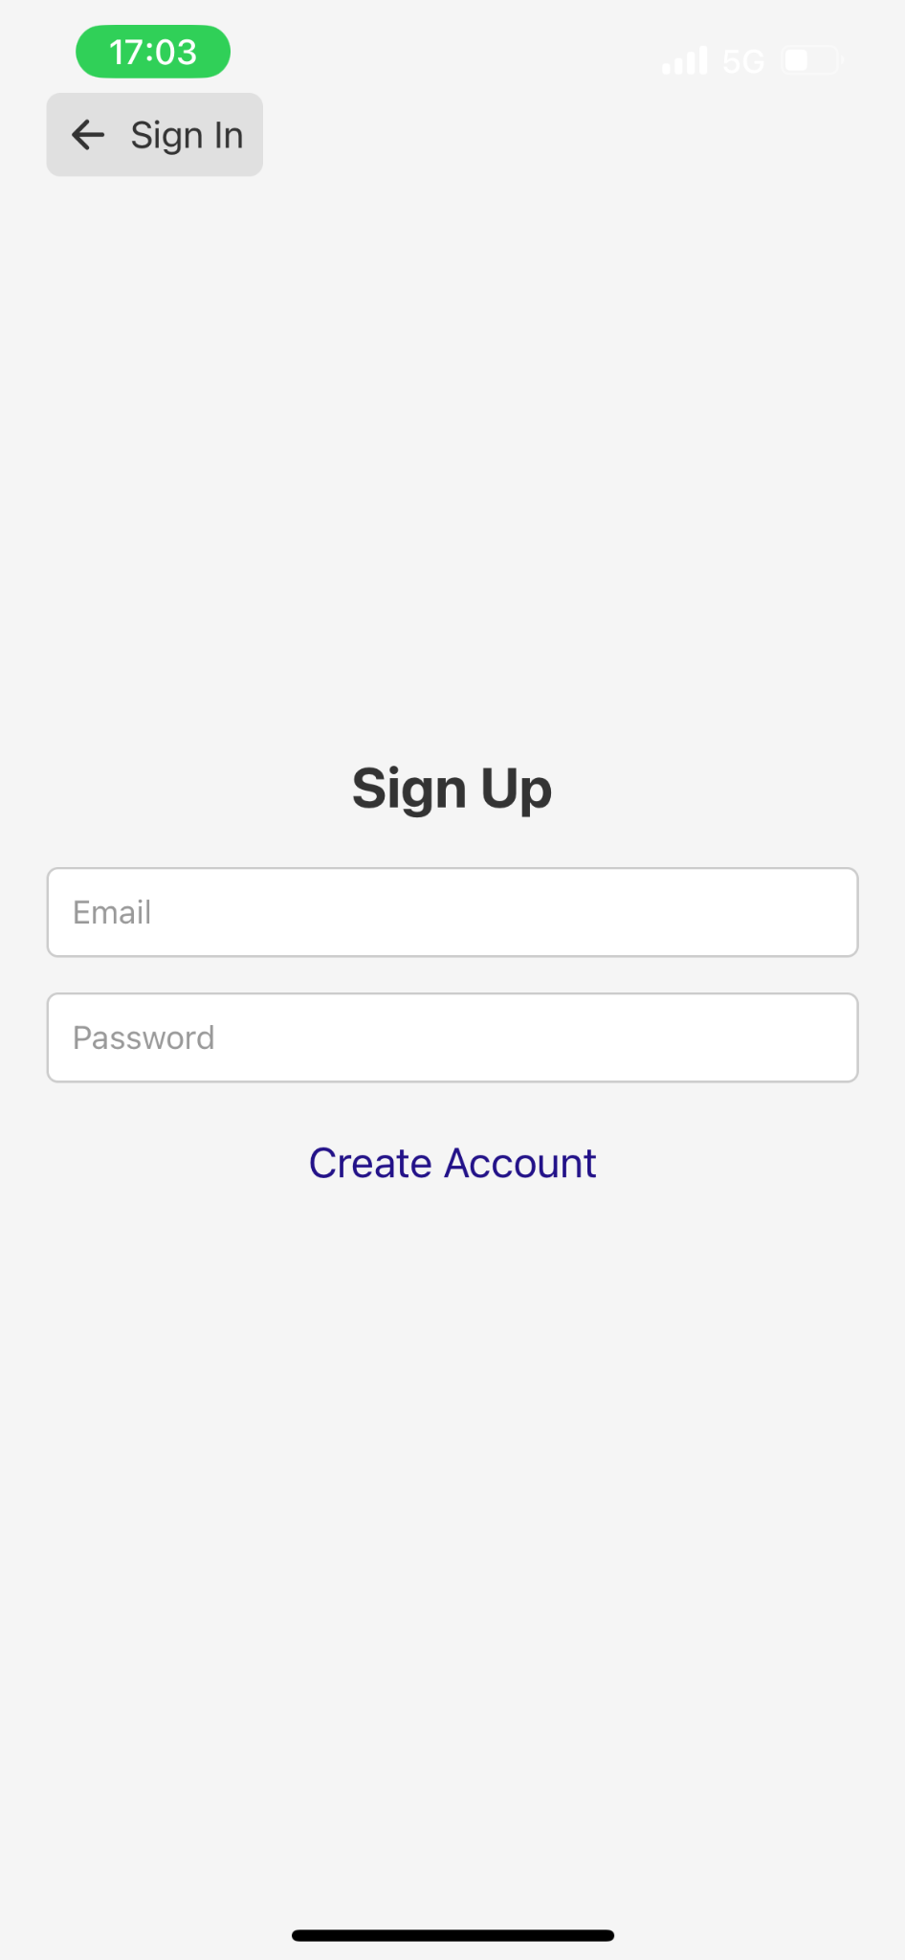
Figure 1. Sign in and Create Account Pages
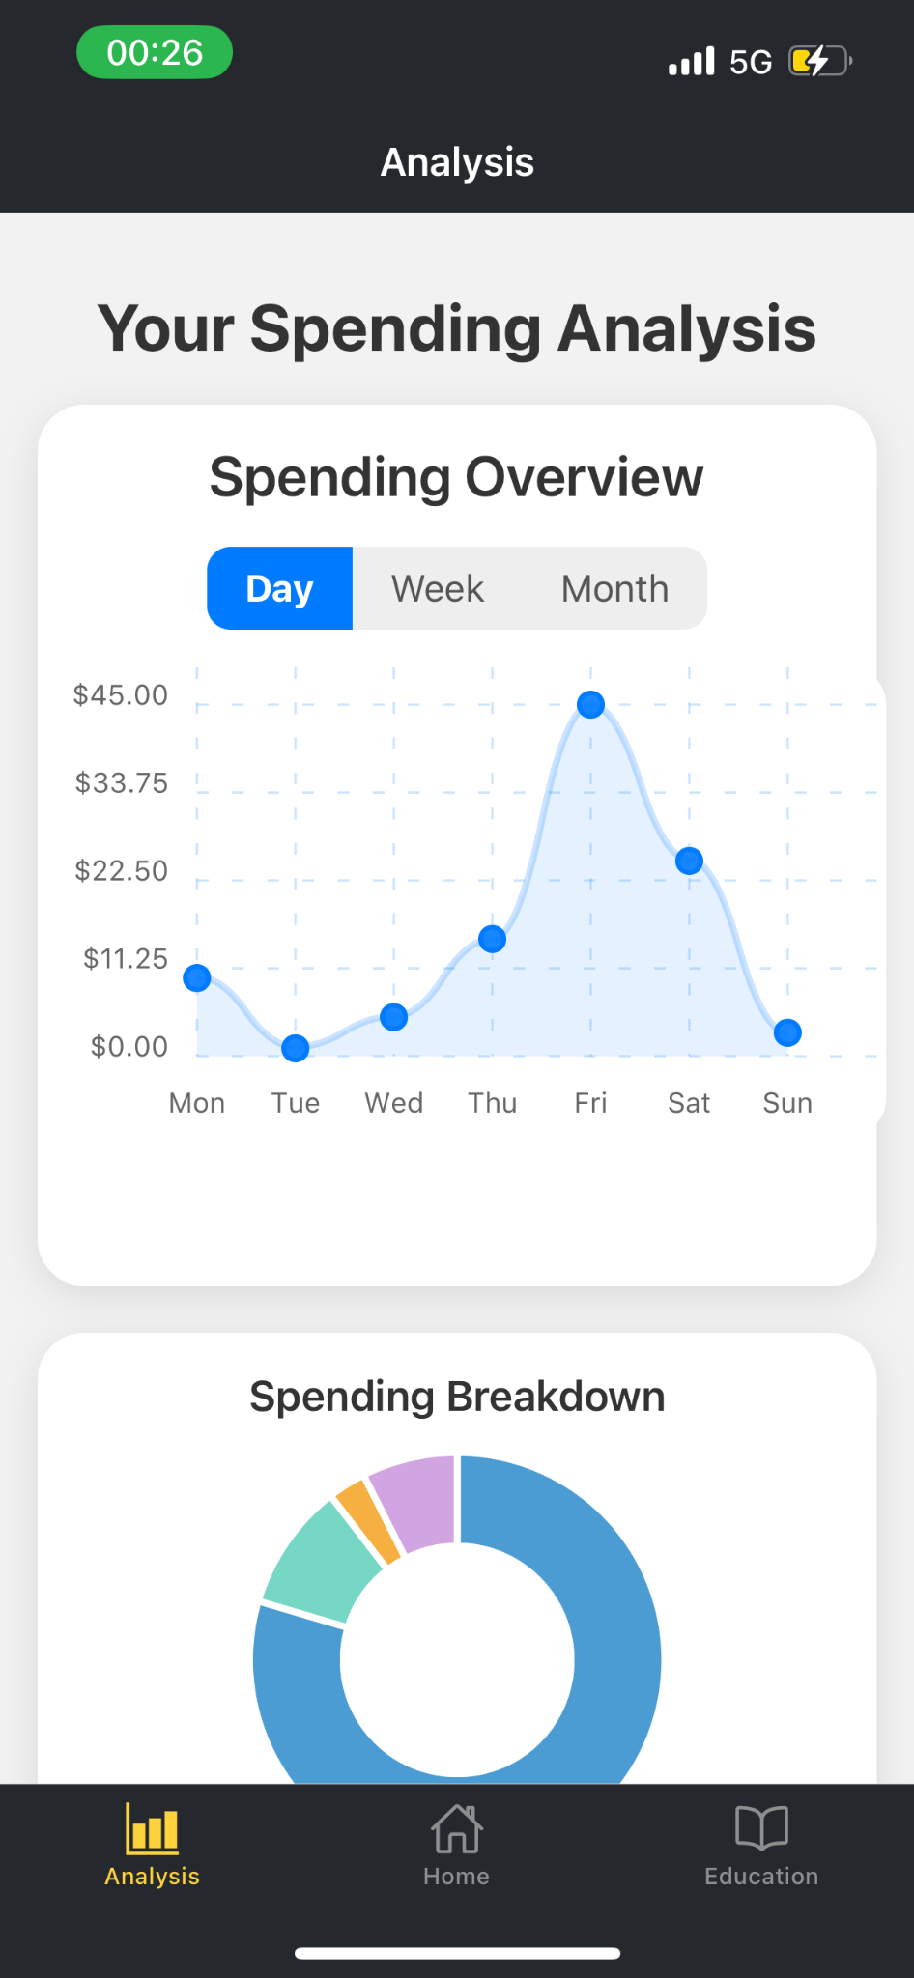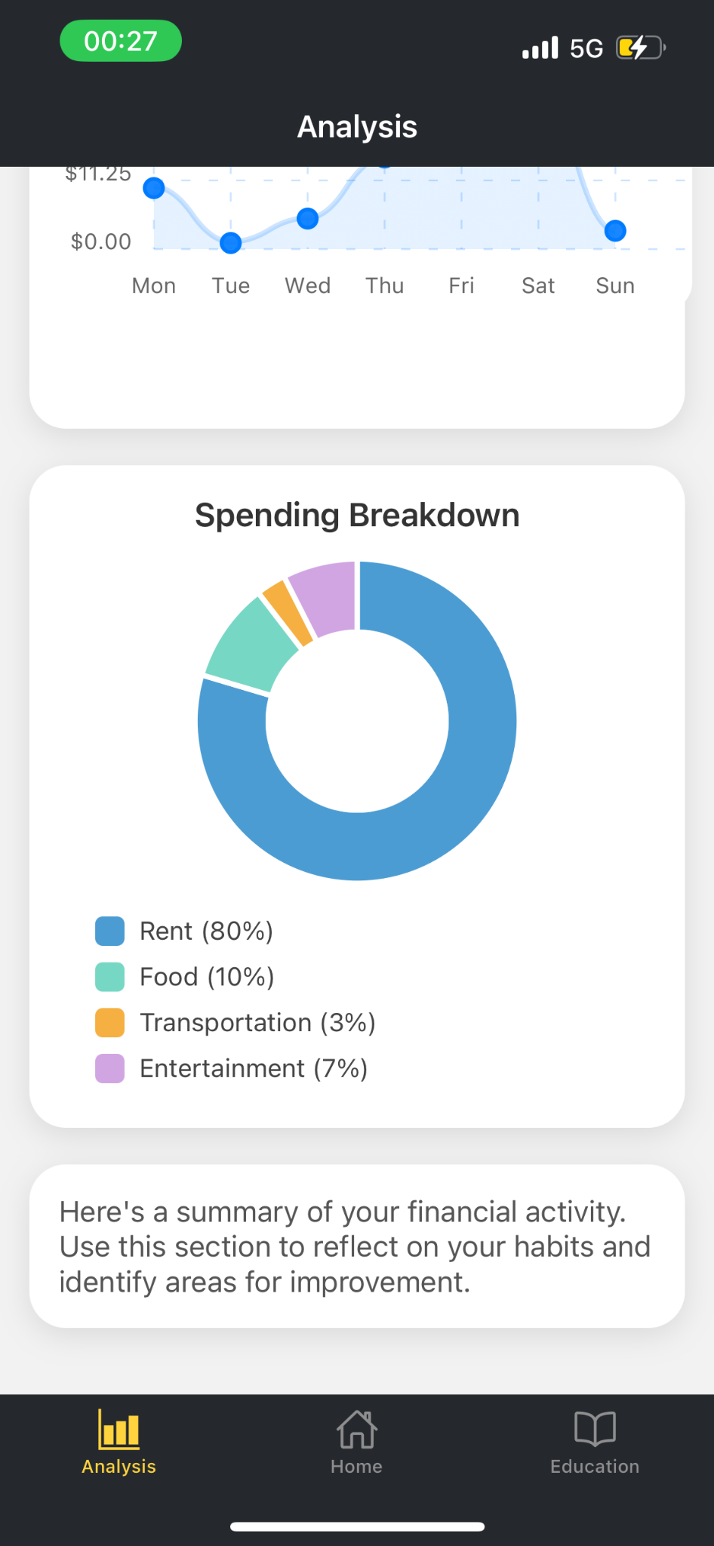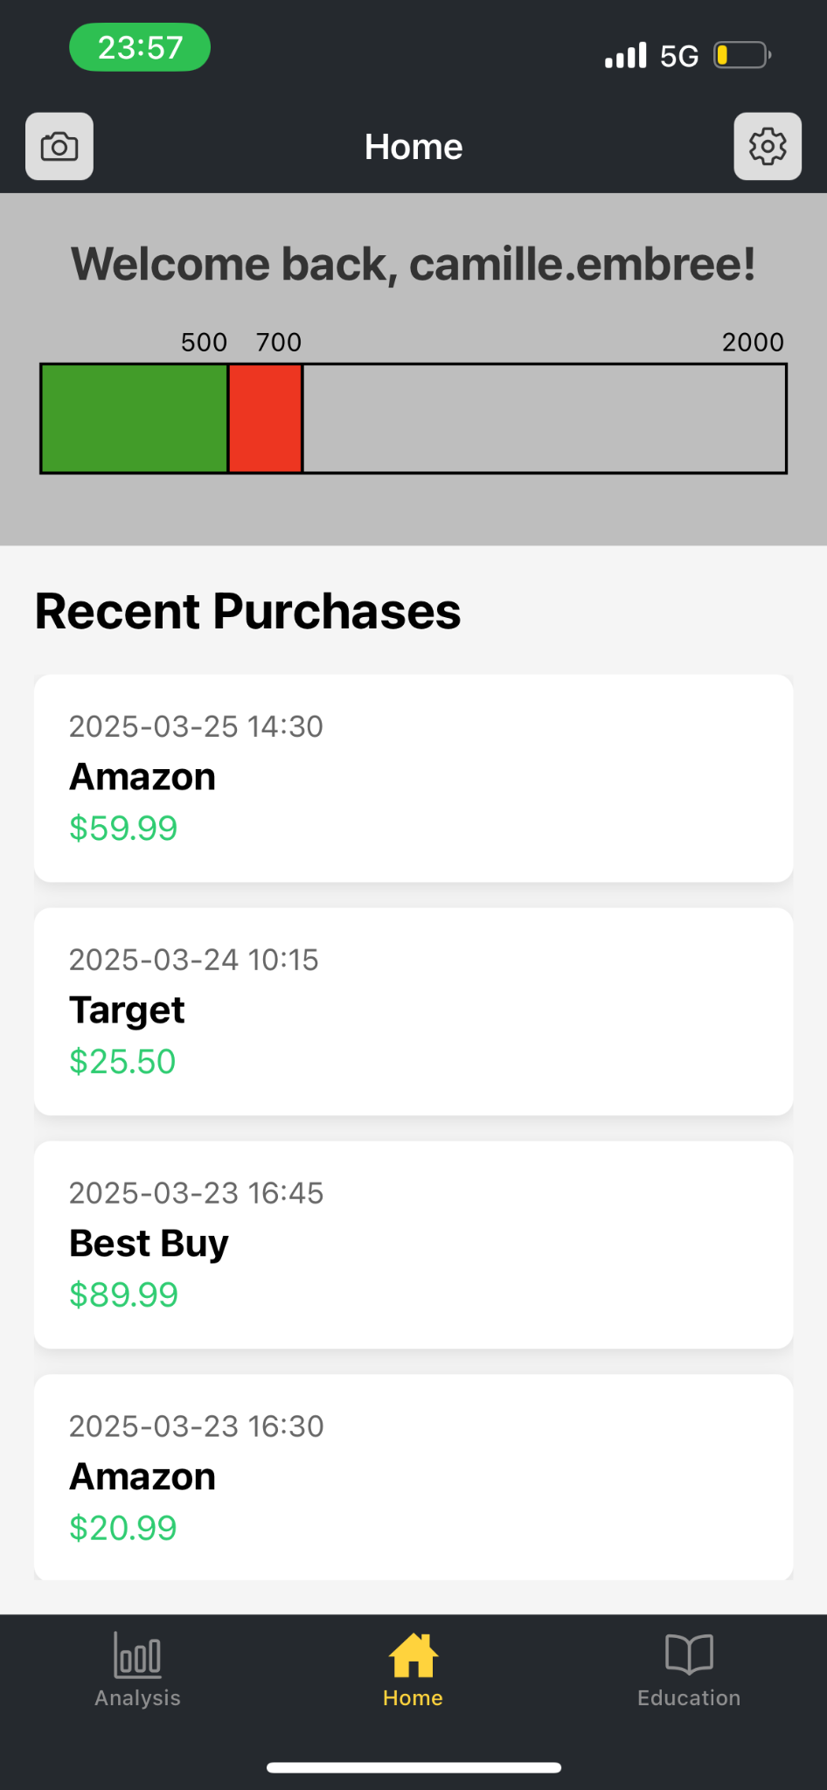
Figure 2. User Interface of Three Main Tabs.

If a user presses on the camera button on the top left of the home screen, they will be prompted to allow the application to access their phone’s camera. If they accept, the camera will open within the app. If a photo is taken, a user can either choose to use the photo or to retake it.

The settings button at the top right of the home screen allows users to navigate to the settings page. Here there are functional options for them to log out, change their password, or delete their account. They can also choose to input personal information that will aid our ML model to provide more helpful financial feedback or suggestions, such as scholarships for specific majors.

Homescreen
The home page of the application is meant to provide an overview of a user’s financial status within a given month. At the top of the page is a basic bar graph that displays both the values for the current expenditures and how much a user should have spent by now, all out of the total budget goal for the month. Below this graph, a scrollable view of the most recent purchases will be available.

There are two functional buttons in the header of this page. These include the camera function and the settings page, as described above. The camera operation will be used to capture receipts/bills to be scanned and processed, primarily for if a user made a cash payment.

Analysis tab
The bottom left tab will include detailed analysis of the financial information provided by firebase. Multiple graphs and charts will be utilized to display these values in a user-friendly manner. There are two primary, the first being a line graph. Here, a user can view their spending trends. They have the option to toggle between viewing their recent expenditures by day (Monday-Sunday), week (4 weeks at a time), or months (6 months at a time). The second is a pie chart displaying the breakdown of how much they spend in each main financial category. At the moment, these are four set categories, however in the future a hope is to implement an option for the user to choose between six to seven categories that our ML model will be able to differentiate.

The user can also view our machine learning models output of suggestions in this tab. This may include suggestions such as “rather than eating out, try to meal prep more often.” These analyses will be gathered from a firebase firestore collection shared with the backend.

  - Education tab
The third and last tab will encourage financial literacy. It will be a page providing easy access to links that may be beneficial to users based on their recent spendings and potentially account information. This page also includes a functioning search bar at the top above the scrollable links list. Users can utilize this function to isolate articles they may have more specific interest in.

  - Code
The code involved in navigation can be primarily found within the _layout.tsx files. As seen in the code organization chart found below in Figure 3, there are two of these files. One is located under the general ‘app’ folder, and the other is in the ‘(tabs)’ folder. The stack setup and a collapsed version of tab organization can be seen in the code below in Figure 4-5. The app/_layout.tsx file first addresses user authentication, verification, and notification registration. The “Other” section of Figure 3 includes files such as firebaseConfig.tsx (a file configuring firebase within the project for easy reference and usage), verify-email.tsx (the page a user is directed to before they’ve successfully verified their email), and +not-found.tsx (a default fall back page that redirects users to the home screen if they’ve wandering onto a nonexistent page).

The index.tsx page referenced in the stack checks if a user is signed in and/or verified, and redirects them based on its findings. It is the homebase of the code.

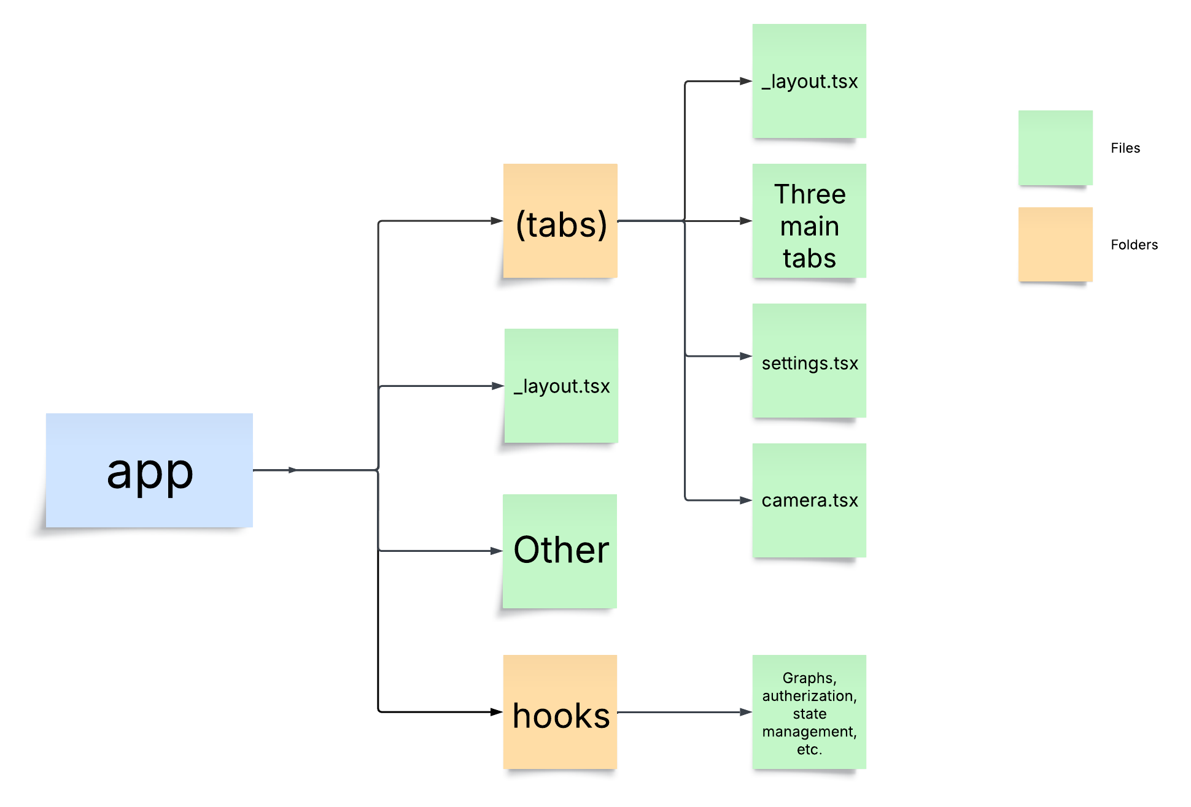
Figure 3. Overview of Code File Organization.

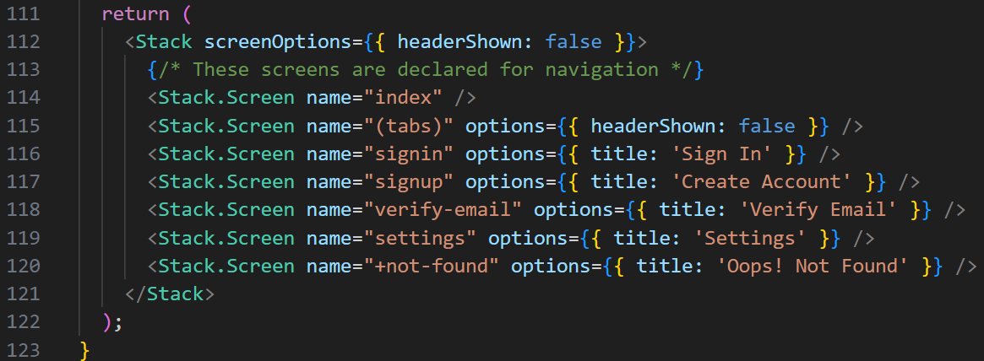
Figure 4. Primary Stack Screen Organization Found in app/_layout.tsx.

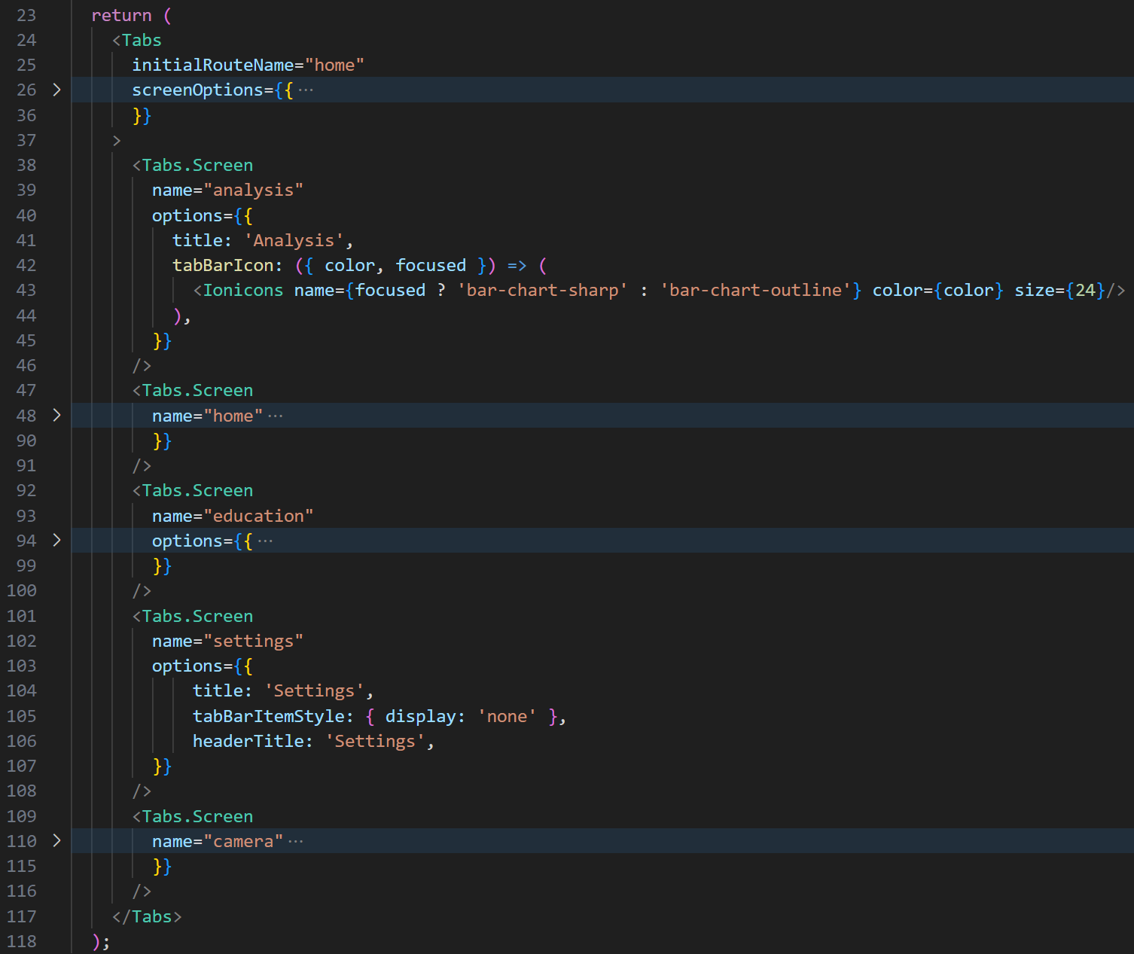
Figure 5. Collapsed Version of Tab Organization found in app/(tabs)/_layout.tsx.

Firebase
Firebase is a platform that provides cloud-based services for application developers. The personalized financial app for students utilizes the tools offered for secure authentication, data/image storage, and notifications. In depth descriptions of how these services are implemented and what each of their purpose entails can be found in the subsections below.

  - Authentication
User authentication is an important aspect of any application. Keeping a user’s private information safe is vital, especially when dealing with financials. Firebase offers up a service that allows for secure user sign-ins. It does this using industry-standard protocols to minimize token leakage, end-to-end encryption in HTTPS/TLS transit, and credential and token encryption at rest within its data centers.

The app uses this service in order to allow users to create accounts and sign in to existing ones. Each new user has their email, password, and unique user ID. If an account is attempted to be created with an email address that already has an account associated, the user is notified of such. Firebase authentication is also used in the frontend code to set up account verification through email to provide another layer of security. Lastly, it’s utilized to allow users to reset their password.

One main file, useAuth.tsx, is located in the app/hooks folder seen in Figure 3. This code determines whether a user is signed in successfully, and holds the current user. There are also a few authentication actions such as sign in, sign up, and sign out. Below is a collapsed code snippet of my useAuth.tsx file.

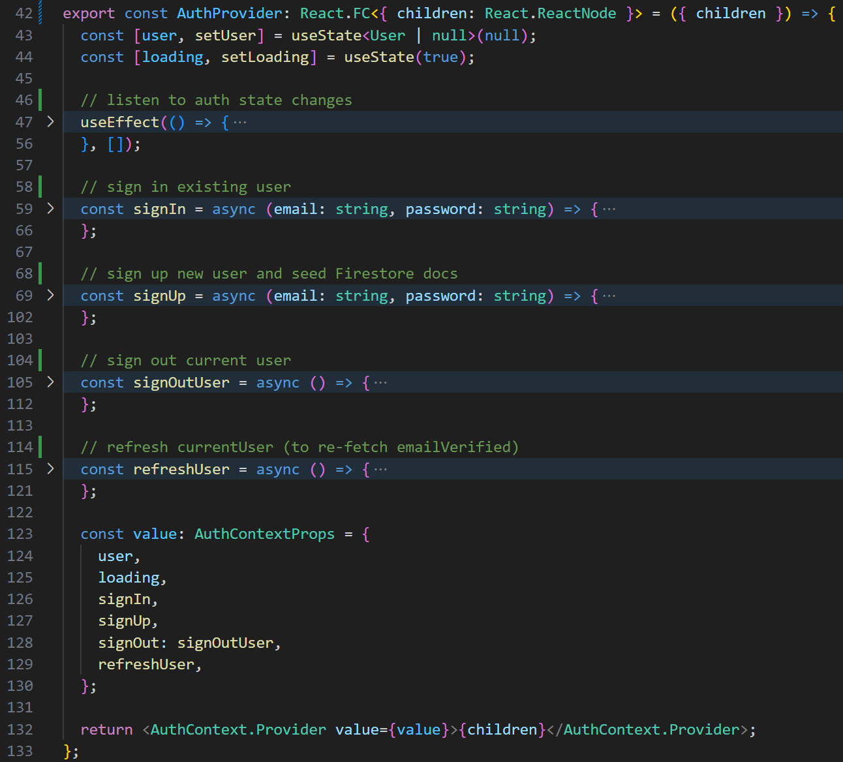
Figure 6. Code Snippet of app/hooks/userAuth.tsx
  - Firestore Database
The next service used in the app is the firestore database. This allows for real time data to be sent and received between a user and Firebase. Instant data propagation will be important when bank integration is complete, allowing for recent purchases and graph values to be constantly updated.

When a new user signs up, multiple documents are created within different collections in the firestore. One example of this is the “budgets” collection. When a new UID is made, so is a document under this collection. One case of this can be seen below in Figure 7. Multiple fields are also created, initially set to 1 until a bank account is successfully integrated. These values are then called through multiple hook files in order to display live information. The imported function “onSnapshot” allows for the data to be updated constantly, rather than just reading it once.

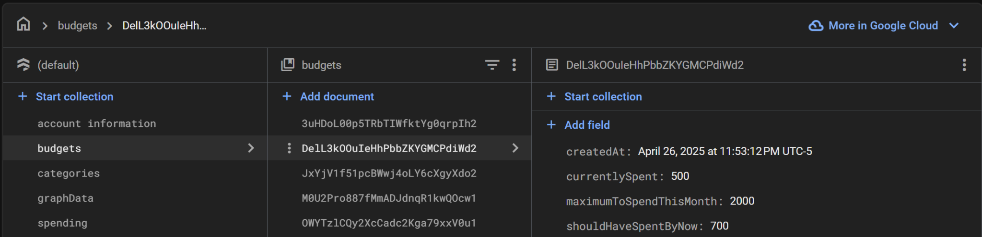
Figure 7. Firestore Organization and Document Creation.

  - Storage
Firebase Storage also holds user data, however it’s more useful for binary or large-blob assets. Each document in the firestore database has a maximum of 1 MB storage. The average file size of a picture of a receipt is 2-3 MB. In order to successfully store the receipt images we plan on using for cash payments, Firebase storage is utilized.

Figure 8 below shows the clip of code that sends the photo to storage. This only occurs after camera access is permitted, a photo is taken, and the user selects the ‘use photo’ option. At the moment, the images are sent to one main folder. When the frontend and backend are combined, there will be a separate folder for each user.

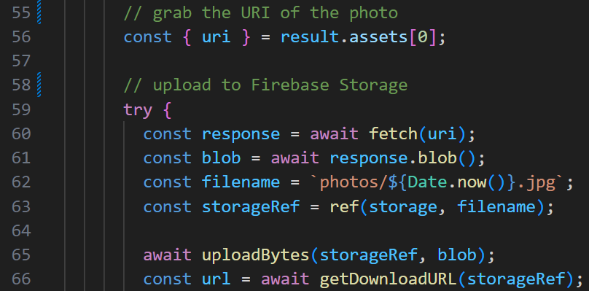
Figure 8. Code Sending an Accepted User Image to Storage.

  - Messaging

Lastly, Firebase messaging is utilized to send push notifications. The file notifications.tsx found in the app/hooks/ folder sends a prompt to users asking them to register for push notifications. Once permission is granted, a unique token is created for this user’s device, and is then sent to firestore. A code snippet of these functions can be found below in Figure 9.

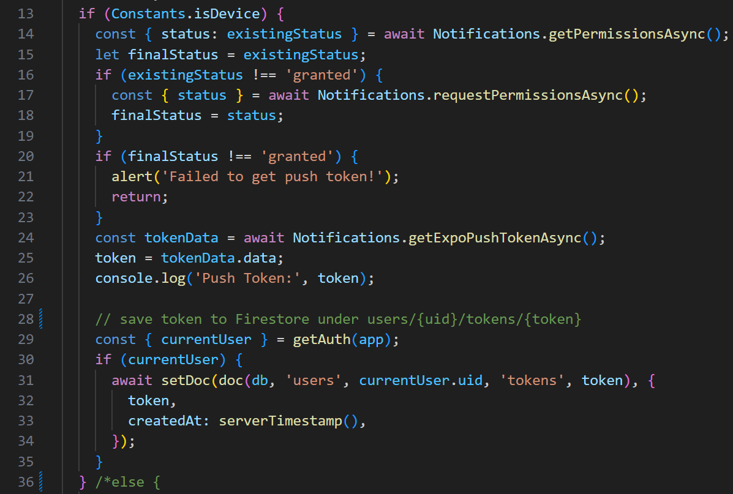
Figure 9. Code Sending a Newly Permitted Token to the Firestore.

Push notifications have been successfully implemented. However, upon integration of the backend, further code will need to be developed in order to determine when certain notifications should be sent. For example, if a user tends to get coffee from a shop everyday at a certain time this will be recognized. An hour before this they might receive a notification reminding them to make coffee at home to bring with them, aiding in their overall savings.

Financial Advisor App for Students
Hoang-Nghi Nguyen

Backend Subsystem Report
Table of Contents
1. List of Tables 61
2. List of Figures 62
3. Introduction 64
4. Firebase Database Integration 65
4.1. Objective 65
4.2. Implementation Details 66
4.3. Validation Results 69
5. Receipt Classification Model 70
5.1. Objective 70
5.2. Synthetic Receipt Data Generation 71
5.3. Implementation Details 80
5.4. Validation Results 83
6. Financial Feedback Generation 85
6.1. Objective 85
6.2. Implementation Details 86
6.3. Validation Results 89

List of Tables
No tables found

List of Figures
Figure 1. Read/Write Time Testbench 67
Figure 2. Read/Write Demo Test 68
Figure 3. Read/Write Test to Firebase 69
Figure 4. Read/Write Time Performance 69
Figure 5. Script for Setting up Training and Evaluation 72
Figure 6. Ensemble Training Script 74
Figure 7. DataProcessor Class Script 76
Figure 8. Classification Prediction Test 78
Figure 9. Transaction Generation Script for Testing Ensemble Model 81
Figure 10. Ensemble Model Test Accuracy and Classification Report 83
Figure 11. Ensemble Training Confusion Matrix 84
Figure 12. Ensemble Training Validation Evaluation 84
Figure 13. Categorized Output after Prediction Classifier Execution 86
Figure 14. Prompt Generation for Financial Feedback 87
Figure 15. Calling OpenAI to Generate Financial Feedback 87
Figure 16. Financial Feedback Response 89

3. Introduction
The backend subsystem serves as the foundation of the Personalized Financial Advisor application’s intelligence and data management capabilities. It is responsible for managing user transaction data, performing automated classification of expenses, and generating personalized financial insights. Without the backend, the application would lack the ability to process raw receipt information, categorize transactions accurately, and deliver actionable financial advice to users.
Designed to operate as a modular data pipeline, the backend handles four major responsibilities:
- Database Management: Efficiently storing, retrieving, and updating user receipt data and processed transactions using Firebase Firestore.
- Data Simulation: Generating synthetic receipt transactions to augment training and testing processes for machine learning models.
- Machine Learning Inference: Classifying incoming receipt transactions into predefined spending categories through a trained ensemble classifier.
- AI-Driven Financial Feedback: Producing customized financial advice by analyzing categorized spending against user-defined budget constraints, leveraging the OpenAI GPT-4 API.
Each subsystem was developed with a focus on reliability, scalability, and automation. The backend was designed not only to support real-time interactions with the frontend application but also to ensure consistent and accurate data processing behind the scenes. The primary goal is to minimize user input burden while maximizing the quality and relevance of the financial feedback provided.
This report outlines the structure, implementation, and validation of the backend subsystem. Detailed sections cover database interactions, synthetic data generation strategies, receipt classification workflows, financial feedback mechanisms, and comprehensive validation results that ensure the system meets performance and reliability expectations.

4. Firebase Database Integration

4.1. Objective
The objective of the Firebase Database Integration subsystem was to establish a reliable, scalable cloud backend that enables secure storage and retrieval of user receipt data. The goal of the Firebase demo was to demonstrate successful basic read and write operations to Firestore, verifying that data could be inserted, retrieved, and managed programmatically through the backend system. Specifically, the demonstration involved writing a sample document containing a message, timestamp, and author identifier, and then reading the document back from the database to ensure data integrity.
Beyond simple functionality, validation of the database performance was also conducted through read and write time tests. These tests measured the latency associated with inserting documents into Firestore and retrieving them afterward, ensuring that operations occurred within acceptable timing constraints for real-time application use. Results from these tests confirmed that the Firebase backend could handle document transactions with minimal delay, supporting the needs of the application’s financial tracking workflow.

4.2. Integration Details
The Firebase integration was implemented using the Firebase Admin SDK for Python, which provides server-side access to Firestore. Initialization of the Firebase application was handled using firebase_admin.initialize_app(), enabling authenticated communication with the Firestore database through a service account credential.
Two primary functions were developed to demonstrate database operations: write_demo_document() and read_demo_document(doc_id). The write_demo_document() function created a new document in the demo collection, containing three fields: a static message ("Message on Firebase"), the current UTC timestamp, and an author field identifying the backend developer. A universally unique identifier (UUID) was assigned as the document ID to ensure that each entry was distinct. The read_demo_document() function retrieved a document from the Firestore database given its ID, verified its existence, and printed its contents to validate that the write operation was successful.
In addition to basic functionality, a benchmarking utility function called benchmark_read_write(n=10) was implemented to systematically test database performance. This function automates the process of writing and reading a configurable number (n) of test documents to Firestore. For each iteration, the time taken to perform the write operation and the read operation is recorded separately. After completing all iterations, the function calculates and prints the average write time and average read time in milliseconds. The test also includes cleanup logic that deletes the test documents after each iteration to prevent database clutter. This benchmarking function provides a clear performance baseline for evaluating the suitability of Firestore for real-time backend operations.

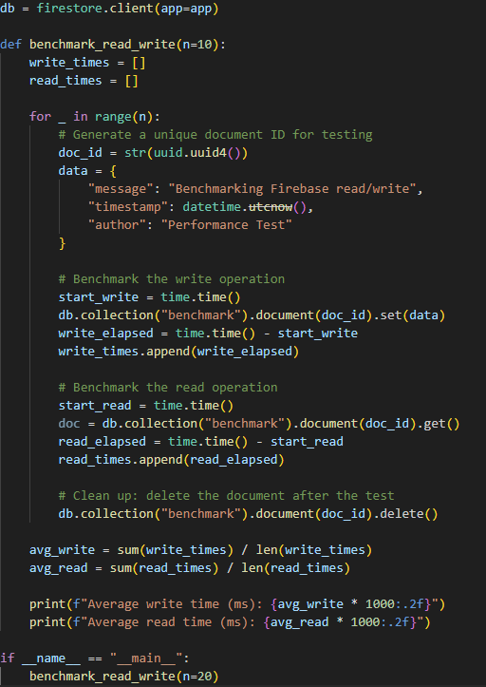
Figure 1. Read/Write Time Testbench
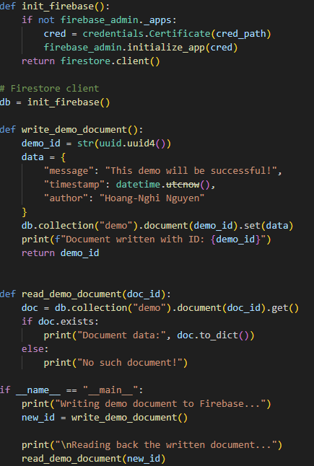
Figure 2. Read/Write Demo Test

4.3. Validation Results
Validation of the Firebase database integration was conducted through both functional correctness testing and performance benchmarking.
First, a demonstration test as shown in Figure 2 was performed using the write_demo_document() and read_demo_document(doc_id) functions. In this test, a document was written to the Firestore demo collection containing a predefined message, timestamp, and author field. After writing, the document was successfully retrieved using its unique document ID, and all fields were correctly preserved. No errors were encountered during the write or read operations, confirming that basic Create and Read functionality works reliably in the backend system.
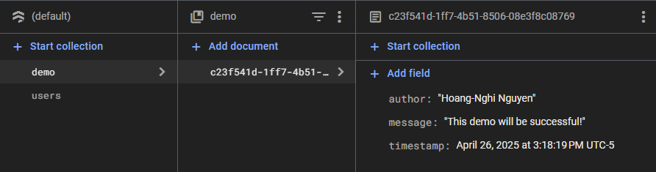
Figure 3. Read/Write Test to Firebase
To further evaluate database performance, a benchmarking test as shown in Figure 1 was executed using the benchmark_read_write(n=20) function. This test automated the process of writing and reading 20 unique documents to and from the Firestore benchmark collection. For each operation, the elapsed time was measured in milliseconds and recorded. After each cycle, documents were deleted to maintain a clean database environment. The resulting average operation times were as follows:
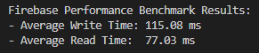
Figure 4. Read/Write Time Performance
These results demonstrate that the backend database operates with low latency, making it suitable for real-time financial tracking applications. No dropped operations or performance failures were observed during the benchmark runs. Overall, the Firebase integration was validated to meet both functionality and performance requirements for the project backend.

5. Receipt Classification Model

5.1. Objective
The receipt classification model is a critical component of the backend system, responsible for interpreting raw receipt text and categorizing each transaction into a specific spending category. This capability enables the application to organize user expenses automatically, reducing the need for manual data entry and improving the accuracy of financial tracking. By classifying receipts into meaningful categories such as Groceries, Dining, Utilities, and Entertainment, the backend system lays the foundation for providing users with actionable financial insights.
The classification model was developed as an ensemble machine learning system trained on synthetic receipt data that simulated real-world transaction patterns. The model’s input consists of extracted text from receipts, typically including merchant names, transaction dates, and amounts. This raw text is first processed into feature vectors using a text preprocessor, after which the vectors are fed into the trained model to predict the appropriate category. The model’s outputs are then decoded back into human-readable category labels, ready for storage and further financial analysis.
This section details the implementation, data generation strategies, system flow, and validation results associated with the receipt classification subsystem.

5.2. Integration Details
The receipt classification subsystem was implemented using a custom-trained ensemble machine learning model. The development process began with the generation of synthetic receipt data using the generate_csv_predict.py script. This script simulated realistic transactions by randomly combining merchants, dates, amounts, and spending categories, producing structured samples that mimic actual user receipts.
To prepare the receipt text for model training, a custom DataProcessor class was developed. This processor converted raw extracted text into numerical feature vectors through a combination of tokenization, encoding, and feature scaling. Key merchant names and numeric fields were encoded in a manner suitable for machine learning algorithms.
The classification model itself was designed as an ensemble of classifiers, combining a Multi-Layer Perceptron (MLP) and Logistic Regression model through a stacking technique shown in Figure 6. The model was trained on the synthetic data and optimized to predict one of several predefined spending categories. After training, the ensemble model and associated label encoder were serialized and saved using joblib for later inference.
At runtime, unseen receipt data is read from a CSV file containing extracted receipt text samples. Each sample is processed into a feature vector using the saved DataProcessor, then passed into the pre-trained ensemble model to predict a numeric category. The numeric predictions are subsequently decoded back into readable category names using the label encoder. This end-to-end pipeline enables automated, real-time categorization of new receipt transactions within the backend system.
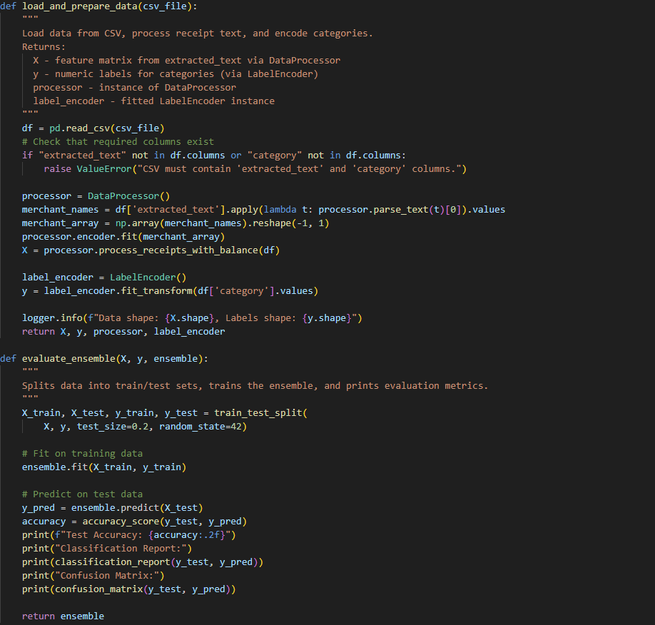
Figure 5. Script for setting up training and evaluation
To support flexible and reusable training workflows, dedicated utility functions were implemented for data loading, preprocessing, and model evaluation:
- load_and_prepare_data(csv_file):
This function loads annotated receipt data from a CSV file, extracts merchant names using the DataProcessor, encodes merchants and category labels numerically, and returns the feature matrix (X), target labels (y), and fitted preprocessing objects.
Key steps include:
  - Parsing merchant names from receipt text
  - One-hot encoding merchant names
  - Label encoding spending categories
- evaluate_ensemble(X, y, ensemble):
This function evaluates the ensemble classifier by:
  - Splitting the dataset into training and testing sets (80/20 split)
  - Training the ensemble on the training data
  - Predicting categories on the hold-out test set
  - Printing evaluation metrics including test accuracy, classification report, and confusion matrix
These utilities allowed for consistent model training and validation workflows, ensuring that each trained model could be quantitatively evaluated against held-out data before deployment.

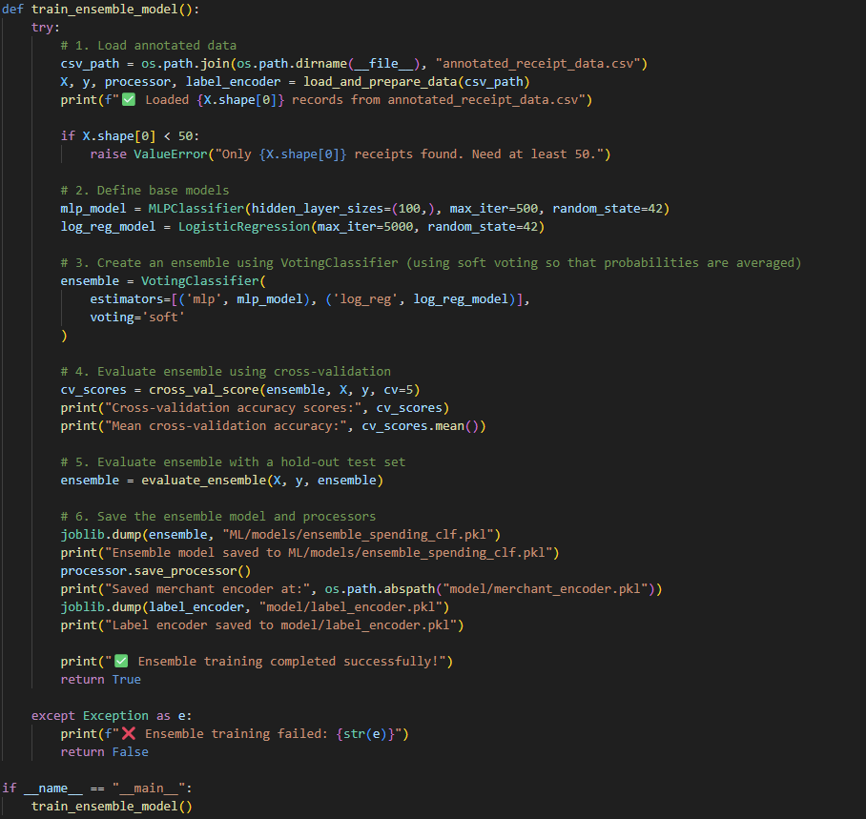
Figure 6. Ensemble training script
The receipt classification model was trained using a modular training pipeline encapsulated in the train_ensemble_model() function. The training process involved several key steps:
- Loading Annotated Data:
The training data, consisting of synthetic annotated receipt samples, was loaded from a CSV file. Text features were preprocessed using a dedicated DataProcessor, and category labels were encoded into numeric format using a label encoder.
- Defining Base Models:
Two base classifiers were defined: a Multi-Layer Perceptron (MLP) and a Logistic Regression model. The MLP model was configured with a hidden layer of 100 units and trained for up to 500 iterations, while the Logistic Regression model was configured with a high iteration limit (5000) to ensure convergence.
- Creating an Ensemble Classifier:
A soft-voting ensemble was constructed by combining the two base models. The ensemble predicted categories by averaging the predicted probabilities from each base model, improving robustness and classification performance.
- Model Evaluation Using Cross-Validation:
The ensemble was evaluated using 5-fold cross-validation on the training dataset. Cross-validation scores were calculated and averaged to assess model consistency and generalization ability.
- Model Evaluation Using Hold-Out Test Set:
After cross-validation, the ensemble model was further evaluated on a hold-out portion of the dataset to measure its real-world predictive performance.
- Saving the Trained Model and Preprocessors:
Upon successful training and evaluation, the trained ensemble model, the DataProcessor, and the label encoder were serialized using joblib and saved to disk for later inference during the backend classification phase.
This training pipeline ensured that the final classification model was rigorously validated, properly saved, and ready for real-time deployment in the backend system.

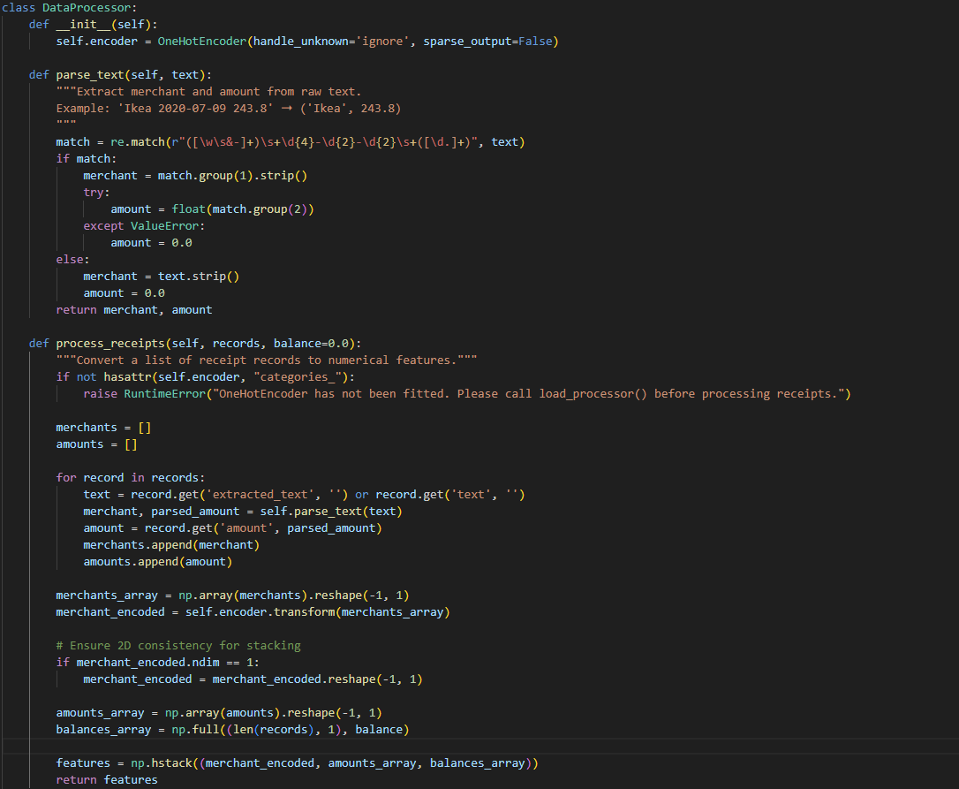
Figure 7. DataProcessor Class script
Before receipt text could be used for machine learning classification, it needed to be converted into a structured numerical feature format. This was accomplished through the DataProcessor class, which handles merchant extraction, amount parsing, and feature encoding.
The processing workflow is as follows:
- Text Parsing (parse_text function):
The raw extracted receipt text, typically formatted as "Merchant Date Amount", is parsed using regular expressions. The merchant name and transaction amount are extracted, while irrelevant parts like dates are ignored.
- Merchant Encoding:
Merchant names are transformed into numerical features using a OneHotEncoder, which encodes each merchant as a unique binary vector.
- Feature Construction (process_receipts function):
For each receipt, a feature vector is constructed by concatenating the one-hot encoded merchant vector, the transaction amount, and an optional balance feature. This stacked feature array is then ready to be used as input for the classification model.
This preprocessing step was crucial for ensuring that the receipt classification model received consistent, structured input that could be effectively used during both training and inference phases.

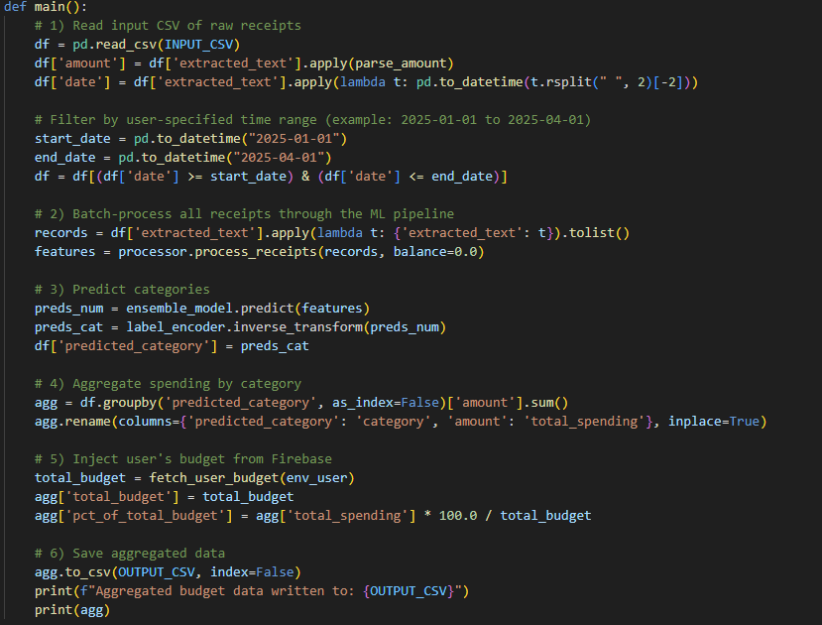
Figure 8. Classification Prediction test
To automate the processing of user receipt data into categorized financial summaries, a structured backend pipeline was implemented. This pipeline performs multiple tasks sequentially:
- Reading and Parsing Input Receipts:
The system loads extracted receipt text from a CSV file. Transaction amounts are parsed from the raw text, and receipt dates are extracted for optional time-based filtering.
- Filtering Receipts by Date Range:
Receipts are optionally filtered based on user-specified start and end dates to allow analysis over specific time periods, such as a single month or semester.
- Batch Processing and Category Prediction:
Each receipt is processed through the DataProcessor to extract merchant and amount features. The processed feature vectors are then fed into the trained ensemble classification model to predict the spending category for each receipt.
- Aggregating Spending by Category:
The predicted categories are grouped, and the total spending amount is aggregated for each category.
- Injecting User Budget Information:
The user's total budget is retrieved dynamically from Firebase. Each category's spending is then normalized as a percentage of the user's total available budget.
- Outputting Aggregated Results:
The final aggregated and normalized financial data is written back to a CSV file. This file is later used for generating financial feedback and visualizations.
This end-to-end pipeline ensures that raw receipt text can be fully transformed into categorized, budget-aware financial summaries in an automated and scalable manner.

5.3. Synthetic Receipt Data Generation
The receipt classification model is a critical component of the backend system, responsible for interpreting raw receipt text and categorizing each transaction into a specific spending category. This capability enables the application to organize user expenses automatically, reducing the need for manual data entry and improving the accuracy of financial tracking. By classifying receipts into meaningful categories such as Groceries, Dining, Utilities, and Entertainment, the backend system lays the foundation for providing users with actionable financial insights.
The classification model was developed as an ensemble machine learning system trained on synthetic receipt data that simulated real-world transaction patterns. The model’s input consists of extracted text from receipts, typically including merchant names, transaction dates, and amounts. This raw text is first processed into feature vectors using a text preprocessor, after which the vectors are fed into the trained model to predict the appropriate category. The model’s outputs are then decoded back into human-readable category labels, ready for storage and further financial analysis.
This section details the implementation, data generation strategies, system flow, and validation results associated with the receipt classification subsystem.
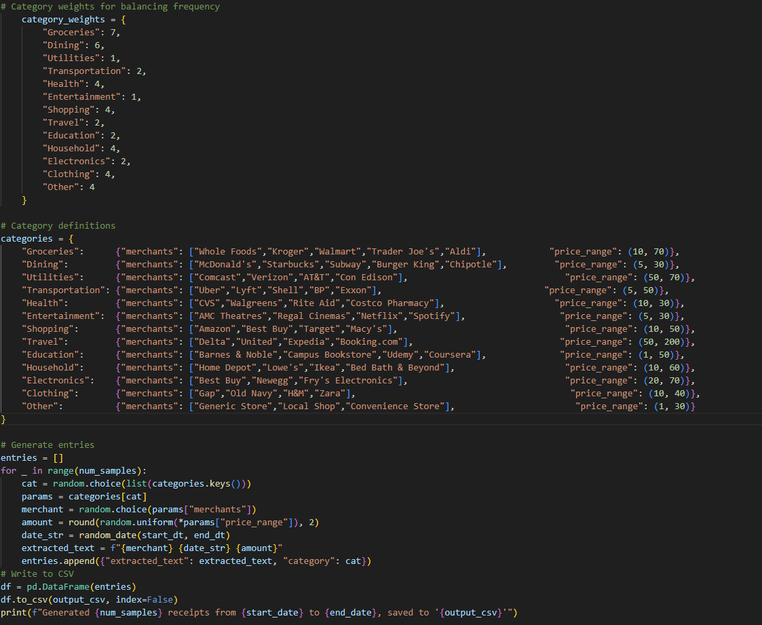
Figure 9. Transaction generation script for testing ensemble model
To simulate realistic receipt transactions for training the receipt classification model, a synthetic data generation script was developed. This script programmatically creates receipt samples by randomly combining merchant names, transaction amounts, and dates, mapped to predefined spending categories.
The script is structured as follows:
- Category Weights:
A weighting dictionary (category_weights) was defined to control the frequency distribution of generated samples across categories. Categories like "Groceries" and "Dining" were assigned higher weights to reflect real-world transaction patterns, while categories like "Health" or "Travel" were assigned lower weights to maintain a balanced yet realistic dataset.
- Category Definitions:
Each spending category was associated with a list of representative merchants and an expected transaction price range. For example, "Groceries" included merchants like Whole Foods, Kroger, and Walmart, with typical spending between $10 and $70.
- Data Generation Loop:
During generation, for each sample:
  - A category was randomly selected based on the weighted probabilities.
  - A merchant was randomly selected from that category's merchant list.
  - A transaction amount was sampled uniformly from the specified price range.
  - A transaction date was randomly selected within a defined date window.
  - The extracted text was formatted as "Merchant Date Amount" and labeled with the corresponding category.
- Data Output:
All generated entries were compiled into a pandas DataFrame and exported as a CSV file for use in training and validating the receipt classification model.
This synthetic dataset provided a scalable and customizable way to simulate realistic receipt inputs, enabling the machine learning model to generalize better across diverse transaction patterns.

5.4. Validation Results
Validation of the receipt classification model was performed using a hold-out test set and 5-fold cross-validation on the synthetic dataset generated for training.
- Hold-Out Test Evaluation:
After training, the ensemble model was evaluated on a 20% split of unseen test data. The following metrics were collected:
  - Test Accuracy and Classification Report
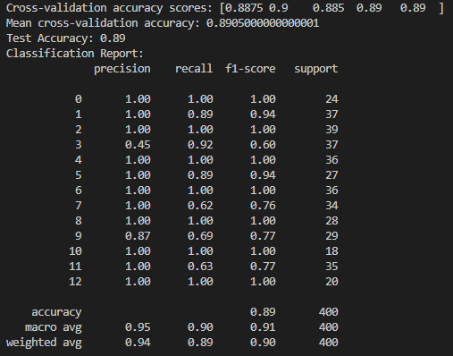
Figure 10. Ensemble Model Test Accuracy and Classification Report

  - Confusion Matrix: Showed that the majority of misclassifications occurred between semantically similar categories such as Shopping and Household, indicating reasonable but improvable model performance.
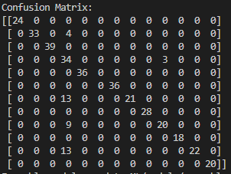
Figure 11. Ensemble Training Confusion Matrix
- Cross-Validation Evaluation:
During training, 5-fold cross-validation was also performed. The cross-validation accuracy averaged around [Insert cross-validation mean accuracy here]% across folds, demonstrating that the model generalizes well across different subsets of the dataset.
Figure 12. Ensemble Training Validation Evaluation
Overall, validation results confirmed that the receipt classification model achieved high accuracy and consistent performance. The model reliably distinguished between diverse spending categories based on merchant names and transaction amounts, supporting its use in automated financial tracking within the backend system.

6. Financial Feedback Generation

6.1. Objective
The objective of the Financial Feedback Generation subsystem is to transform categorized user transaction data into personalized financial advice. After user receipts are processed, categorized, and aggregated relative to their budget, the backend system generates automated insights to help users better understand and manage their spending behavior.
The goal of this subsystem is to deliver actionable recommendations based on the user's real financial patterns, identifying areas of overspending, suggesting saving opportunities, and providing overall financial health assessments. To achieve this, the aggregated budget data is structured into a dynamic prompt, which is then submitted to OpenAI’s GPT-4 model. The AI agent analyzes the user’s spending distribution, compares it to their declared budget, and generates personalized feedback in natural language.
By automating the feedback process, the system reduces the need for manual financial coaching, scales advice delivery to a large number of users, and enhances the app’s ability to deliver meaningful, user-specific financial support in real time.

6.2. Implementation Details
The Financial Feedback subsystem begins by reading an aggregated CSV file that is output by the ensemble model, which summarizes user spending per category along with the total monthly budget. Each row in the input CSV contains the spending category, total amount spent, and the corresponding percentage of the total user budget.
To prepare the data for AI processing, the system constructs a dynamic prompt using the generate_prompt_from_aggregated() function. This function formats the aggregated financial data into a natural-language list, describing each category’s spending relative to the user's budget. The prompt also instructs the AI to provide personalized financial feedback, including advice on areas of overspending or savings opportunities.
Once the prompt is constructed, it is sent to OpenAI’s GPT-4 model via the get_financial_feedback() function. The OpenAI API is called securely by loading the API key from a .env file using the dotenv library. The GPT-4 model analyzes the structured financial input and generates personalized feedback in natural language, tailored to the user's actual spending behavior and budget goals.
The returned feedback is printed or stored for further use in the application frontend, providing users with automated, high-quality financial advice based on their real transaction history.
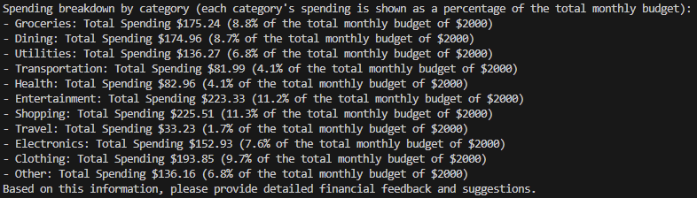
Figure 13. Categorized Output after Prediction Classifier Execution
This output from the ensemble model highlights the percentage of the user’s spending in categories compared to their set monthly budget, which is then given to the AI agent for financial feedback generation
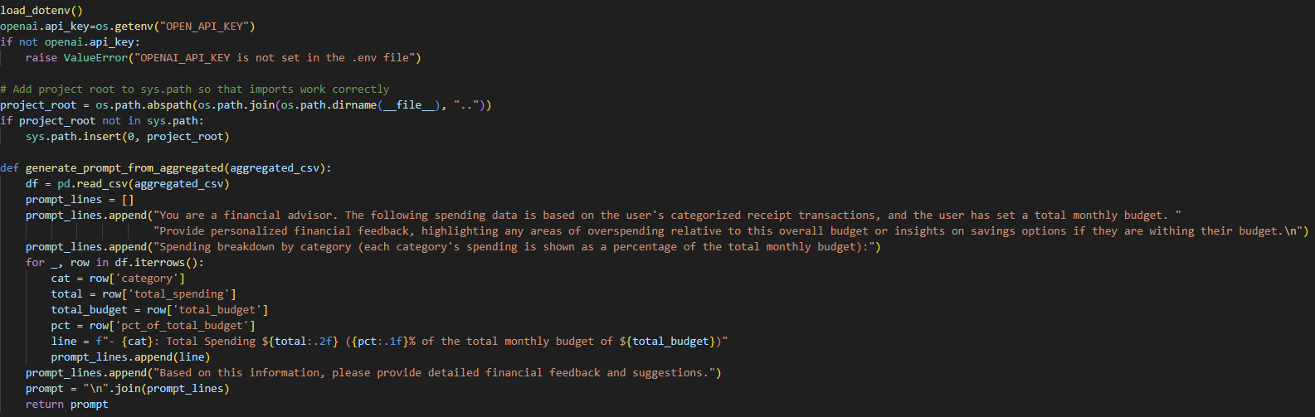
Figure 14. Prompt Generation for Financial Feedback
This code constructs a structured natural language prompt for financial feedback generation. The generate_prompt_from_aggregated function reads aggregated user spending data from a CSV file, formats each spending category with its corresponding total and percentage of the user’s monthly budget, and builds a financial overview statement. This prompt is later submitted to the OpenAI GPT-4 model to generate personalized financial advice. Additionally, the script securely loads the OpenAI API key from a .env file to ensure proper authentication for subsequent API calls.
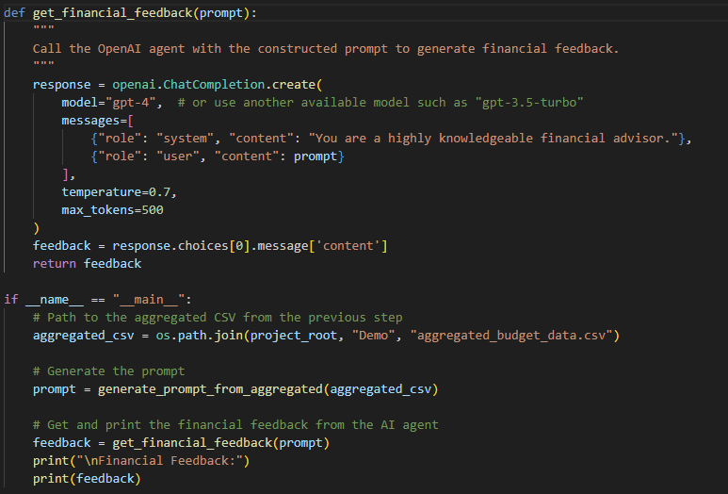
Figure 15. Calling OpenAI to Generate Financial Feedback
This code defines the function get_financial_feedback, which sends a user-specific financial prompt to the OpenAI GPT-4 model and retrieves personalized financial advice. The constructed prompt, containing categorized user spending information, is sent as a user message to the AI agent. The AI responds with detailed recommendations based on the user’s spending relative to their total budget. The __main__ execution block demonstrates a full workflow: loading the aggregated spending CSV, generating the prompt, querying the AI model, and printing the resulting financial feedback.

6.3. Validation Results
Validation of the Financial Feedback subsystem was conducted through manual review of generated AI feedback based on various user spending scenarios. After submitting aggregated spending summaries to the OpenAI GPT-4 model, the returned feedback was assessed for logical coherence, relevance to user financial behavior, and alignment with the provided budget constraints.
The AI consistently identified areas of overspending when individual category expenditures exceeded reasonable budget percentages, and provided meaningful savings suggestions when users maintained spending discipline. Example feedback included advice such as reallocating excess dining expenses toward savings goals or commending efficient grocery budgeting.
Across multiple test cases, feedback outputs were found to be logically consistent, budget-aware, and contextually appropriate, confirming that the subsystem can reliably provide users with personalized and actionable financial advice. No major hallucinations or irrelevant responses were observed during testing.
Overall, the Financial Feedback Generation module was validated to meet the requirements for automated, scalable, and context-sensitive financial advice delivery.
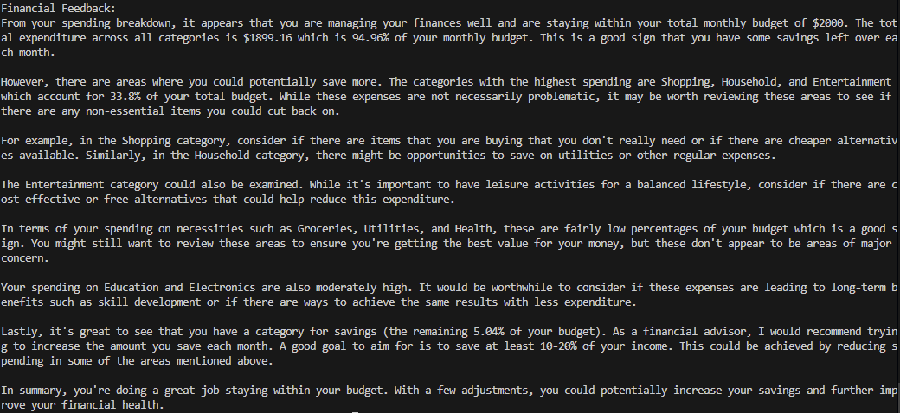
Figure 16. Financial Feedback Response

